Angular

**

Table of Contents

1. Introduction to Angular 8

2. Loading & Start up process 8

3. Angular components 9

4. Components through CLI and Nesting 11

5. Component Templates 13

6. Component Styles 15

7. Understanding Selectors 16

8. Data binding 19

9. String Interpolation 20

10. Property binding 21

11. String Interpolation vs Property Binding 22

12. Event binding 22

13. Bind able Properties and Events 23

14. Passing and Using the data with Event Binding 24

15. Two Way Databinding 25

16. Directives 28

17. Attribute Directive: ngStyle 30

18. Attribute Directive: ngClass 31

19. Structural directive ngFor 33

20. Accessing index using ngFor 35

21. Binding Custom properties 36

22. Assigning alias to custom properties 40

23. Binding Custom Events 41

24. View Encapsulation 44

Type 1: None 44

Type 2: Emulated 46

Type 3: ShadowDom 48

25. Using local reference in templates 48

26. Accessing Template and DOM through @ViewChild 49

27. Projecting content into components using ng - content 50

28. Component lifecycle hooks 51

29. Lifecycle hooks and template access 54

30. Getting access to ngContent using @ContentChild 56

31. Adding navigation with event binding and ngIf 57

32. Passing data with property binding 60

33. Implementing Add functionality to shopping list 61

34. Passing data with Event and property binding 63

35. Attribute VS Structural directive 67

36. Creating a basic attribute directive 67

37. Building attribute directive using renderer 70

38. Using Host listeners to capture events 71

39. Using Host binding to access properties of an element 72

40. Binding to directive properties 73

41. Behind the scenes of a structural directive 76

42. Creating custom structural directive 78

43. ngSwitch Structural directive 80

44. Working on custom attribute directive 82

45. Service and Dependency injection 83

46. Creating Data services and Hierarchical Injector 88

47. Injecting one service into another 91

48. Using Service for cross component communication 95

49. Assignment: Services and dependency injection 97

50. Enhancing Recipe – Shopping application with services 106

51. Cross Component Communication through Services 112

52. CSS 127

a) Tag: div 127

b) HTML Classes 127

53. Reference 127

# Introduction to Angular

It is a JavaScript framework which is used for creating reactive single page application.

Project Setup:

* Command to Create new project: ng new <Project-name>
* Command to initiate build and deploy the same in a development Server: ng serve
* Project Setup using bootstrap for styling: npm install - -save bootstrap@3
* Modify the “angular.json” file to incorporate the boot strap styling.

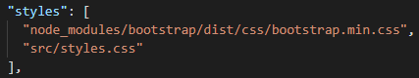

# Loading & Start up process

The segment of code contained in the file “main.ts” will be the starting path of execution for any angular application. Moving on the “main.ts” in turn holds reference to “app.module.ts” file which in turn encapsulates “app.component.ts” which provides the definition for the “app-root” element of the “index.html” file through a selector.

The “index.html” file is the single page that gets rendered on the browser at all times. When the “ng serve” builds the application, it does so by creating various modules out of the complete application and then importing the same on to the “index.html” file in the appropriate section.

The following diagram represents the flow of application start up sequence.

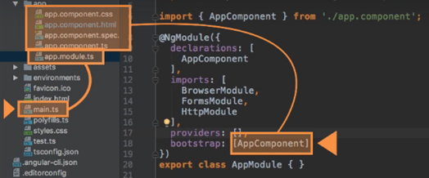

# Angular components

Components are the most basic building blocks of an angular application. An Angular application contains a tree of angular components.

An Angular component is a subset of directives, always associated with a template. Unlike other directives, only one component can be instantiated for a given element contained in a template.

A component must in turn belong to an NgModule for it to be available for other components and application. In order to nominate a component to be a member of an NgModule, simply add the component to the declaration field in the metadata of the NgModule.

The following would be the sequence of steps in creating a new angular component.

**Step 1**: Create a new folder with the name representing the need of the component.

**Step 2**: Create the type script which would in turn export a class using decorators as an angular component and provides information on how the class must be processed, instantiated and used at run time.

Fig: Illustration of the new component directory structure

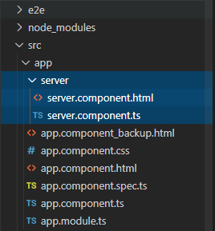

Fig: server.component.html file

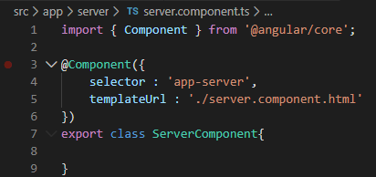

**Step 3**: Create the html file that would be referenced by the server component at runtime.

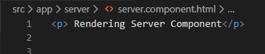

**Step 4**: Modify the app.component.html file to incorporate the selector which would exhibit the behaviour of server component.

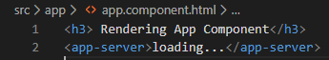

**Step 5**: Adding the new component into the declaration of the NgModule.

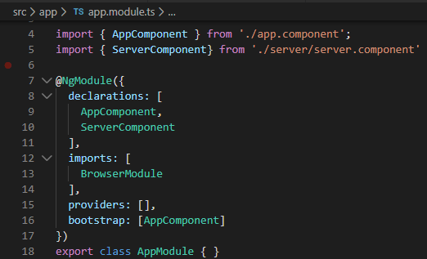

**Output**:

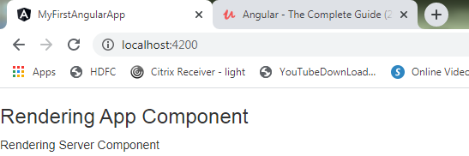

# Components through CLI and Nesting

The following is the command to create any elements such as a component through CLI.

***Command***: ng generate component <*Component_Name*>

In the following illustration we would create new component named as “Server” which would in turn have set of nested “Server” components.

Command: ng generate component servers

Fig: servers component created through CLI

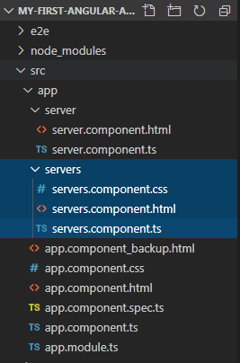

We would incorporate the selector of server’s component into “app.component.html” file and the “servers.component.html” would have the selector of server component.

File: app.component.html

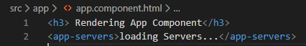

File: servers.component.html

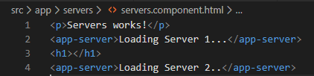

File: severs.component.ts

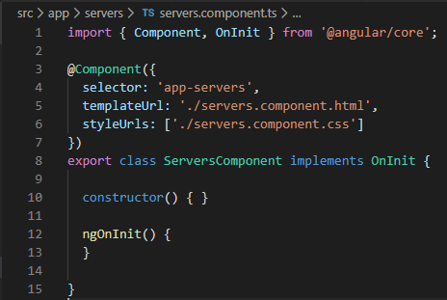

Output:

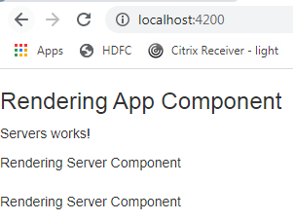

# Component Templates

The metadata section of the type script that is used to configure the HTML content can be done through the attribute “template” or “templateUrl”, but the presence of either one of them is mandatory.

The difference among them is that while “templateUrl” is used to provide reference to an external HTML file, “template” attribute can be used to enclose the HTML code within the type script file.

If the HTML Code is of one liner the value can be enclosed in single quotes or in the event if it is a multiline the data can be enclosed within back ticks.

File: servers.component.html

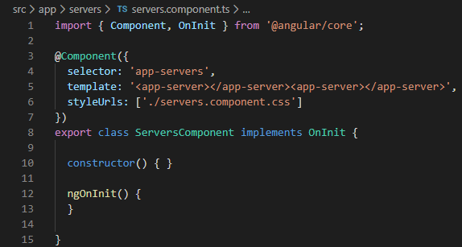

File: servers.component.html using back ticks

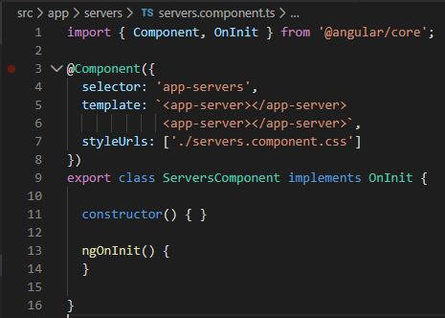

# Component Styles

The style of a component is defined by the file associated to the attribute “styleUrls” or “styles” present as a configuration within the @Component decorator.

Unlike template configuration Styles is an array of elements which allows developer to refer and reuse multiple files in a component.

The “app.component.html” file is modified to incorporate few CSS classes and we define the styling of the elements in the “app.component.css” file.

Example: The following example is an illustration of styleUrls attribute

File: app.component.ts

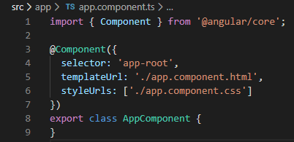

File: app.component.html

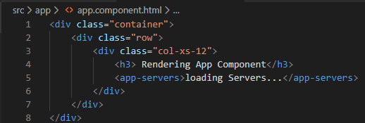

File: app.component.css

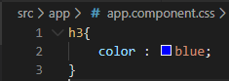

Replacing “styleUrls” with “styles” attribute in the app.component.ts file.

Fig:

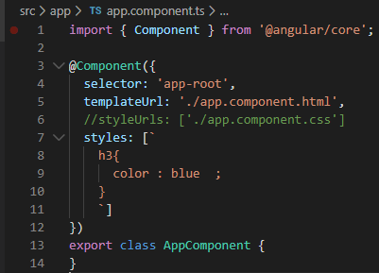

**Output:**

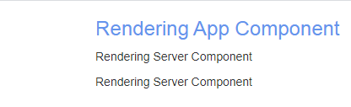

# Understanding Selectors

There following are the three different ways of configuring the selector attribute within the @Component decorator.

1. *Selector as an HTML Element*

In this approach the selector is initialized with the value same as the name of the HTML element.

File 1: servers.component.ts

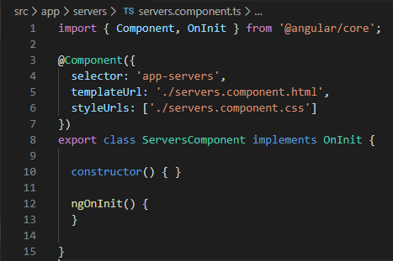

File 2: server.component.html

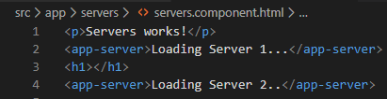

1. *Selector as an attribute –Standard approach*

In this type the selector attribute is initialized with the value in a square bracket which refers to the element enclosed in a <div> tag within the respective HTML file.

File: servers.component.ts

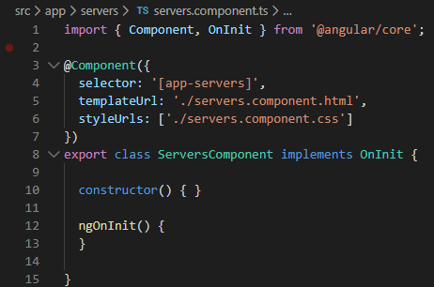

File 2: app.component.html

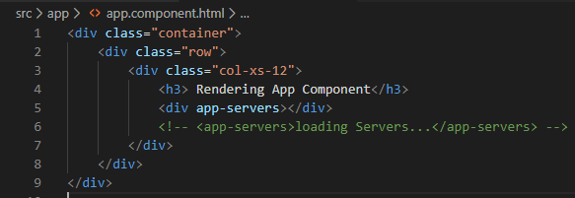

1. *Selector as a class*

The aforementioned type allows us to define the selector with a value that is declared as a class within the corresponding HTML file.

File 1: servers.component.ts

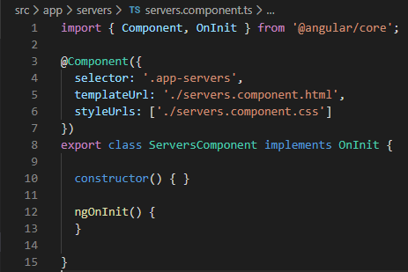

File 2: app.component.html

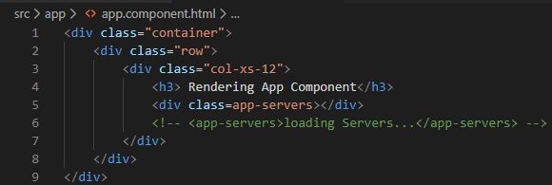

# Data binding

The idea is to render the data from the type script on to the respective HTML element. On the same lines Event binding allows user to associate an event to an expression on the typescript end.

Angular allows us to implement the both of the bindings through Two-Way Binding

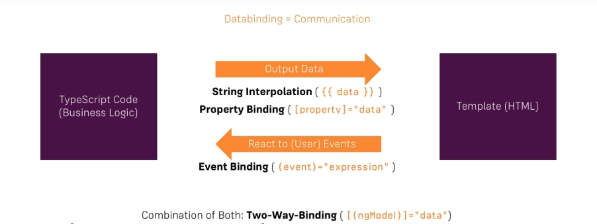

# String Interpolation

It is process by means of which the data defined in type script is interpolated into the place holder within a HTML file. The String Interpolation works successfully only if the data is of type string or can be converted to string.

File: servers.component.ts

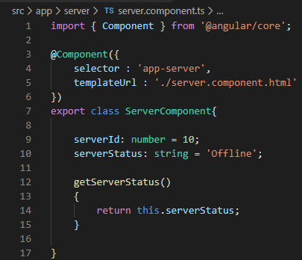

File: servers.component.html



# Property binding

It is a means by which we define the behaviour of an HTML element, directives or custom components at runtime using ECMA Script.

File: servers.component.ts

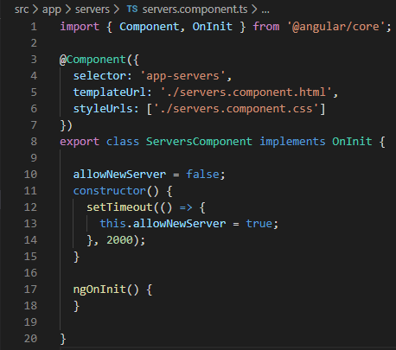

File: servers.compnent.html

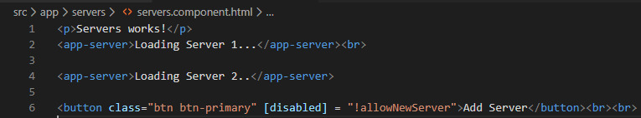

# String Interpolation vs Property Binding

**String interpolation** Is used in scenario where the value is expected to be streamed to an output console. For example, a message within the paragraph element.

Whereas the **property binding** is used for defining the behaviour of an HTML element, directive or component at runtime.

The following snap shot serves as an example on the usage of Property binding and String interpolation.

File: servers.component.html

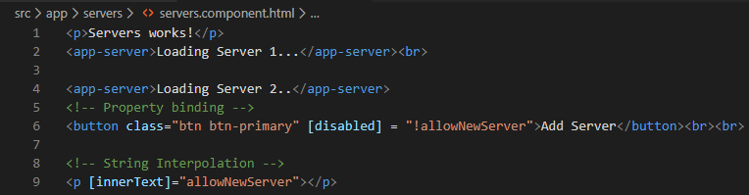

In the afore mentioned example the “innerText” attribute is used to define the literal that is enclosed within the element. In other it is an alternative for the below mentioned syntax.

Example: <p> {{ allowNewServer }} </p>

# Event binding

It Is the process of binding an event to a custom logic that is to be executed upon the occurrence of an event. In order to do so we can initialize the “click” attribute of the HTML element with the name of the function which will be executed once the event occurs.

File: server.component.ts

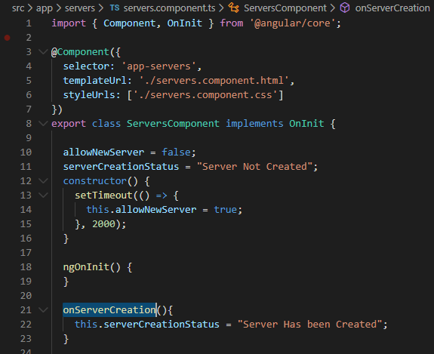

File: server.component.html

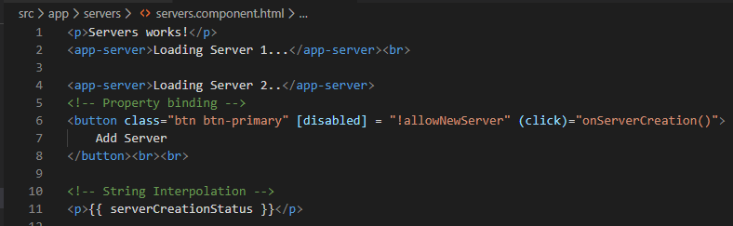

# Bind able Properties and Events

How do you know to which Properties or Events of HTML Elements you may bind? You can basically bind to all Properties and Events - a good idea is to *console.log()* the element you're interested in to see which properties and events it offers.

Important: For events, you don't bind to onclick but only to click (=> (click)).

The MDN (Mozilla Developer Network) offers nice lists of all properties and events of the element you're interested in. Googling for YOUR_ELEMENT properties or YOUR_ELEMENT events should yield nice results.

# Passing and Using the data with Event Binding

In order to pass the data being entered into an input field, we will initialize the “input” attribute to a method defined in the typescript and method call will incorporate an inbuilt argument named as “$event” which holds all the data associated to a particular event.

In our case it would help in retrieving the text entered in the input filed which will then be initialized to a variable and the same gets interpolated on to an element in the HTML file.

The various attributes associated to the $event variable can be explored by logging the same on the console.

File: server.component.ts

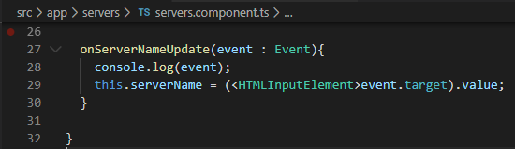

File: servers.component.html

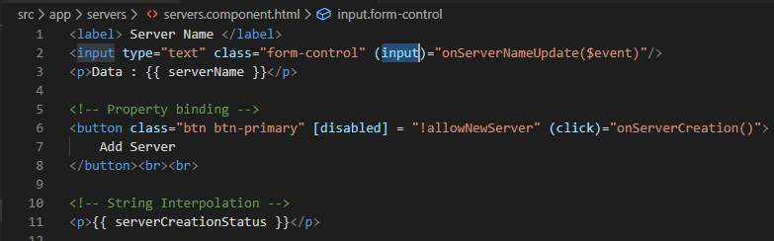

Output:

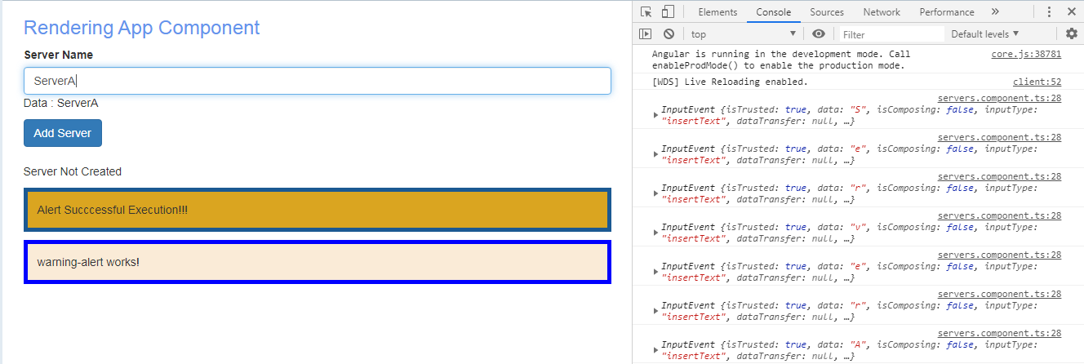

# Two Way Databinding

In order to use the ngModel, the forms are to imported in the app.module.ts.

In this approach we bind the data of an event to the implementation in the type script and same gets reflected in all the further references in the HTML file.

The “ngModel” directive is used to perform the two-way data binding and it does so by binding the data to the “serverName” variable in the type script, on the occurrence of an event and the same data gets rendered back in the HTML element that refers to “serverName” variable.

File: app.module.ts

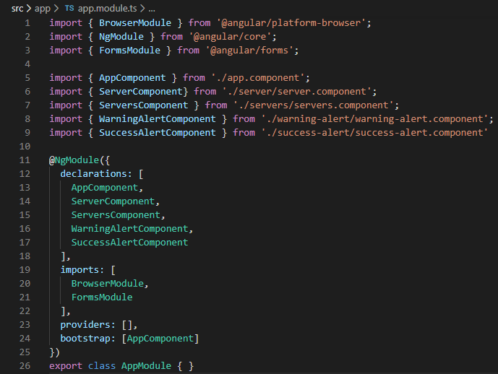

File: servers.component.ts

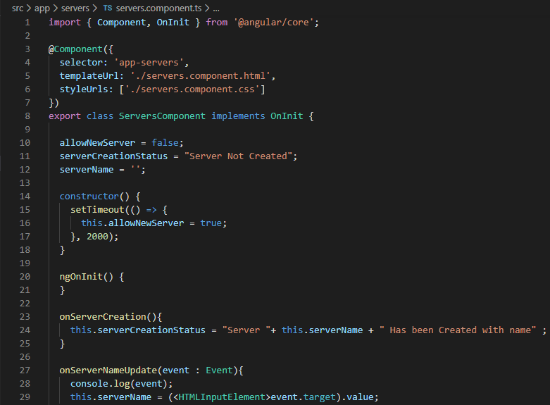

File: servers.component.html

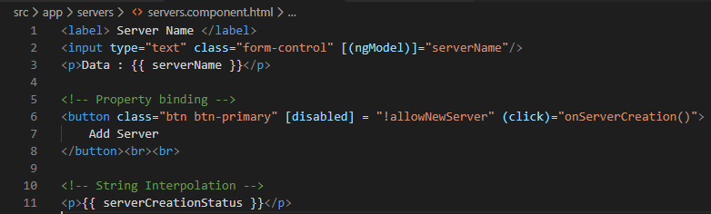

# Directives

It is a function that executes whenever the Angular compiler finds it in the DOM. Angular directives are used to extend the power of HTML by giving it a new Syntax.

The * symbol as prefix to a directive indicates that it is a Structural directive upon execution of which it would change the structure of the DOM.

Directive name: ngIf

File: servers.component.ts

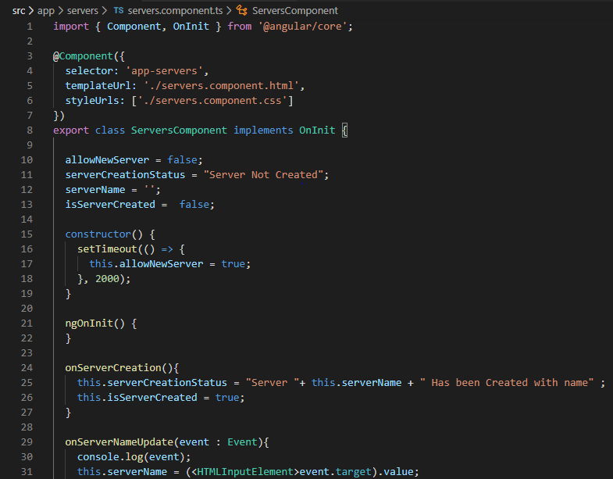

File: servers.component.html

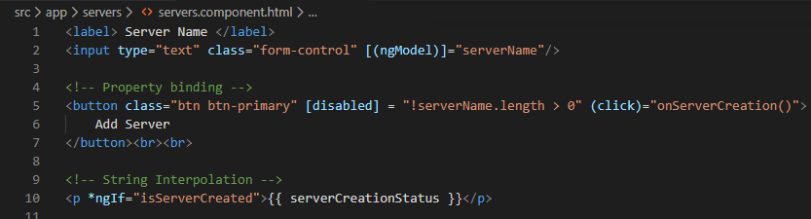

Output: Before Event

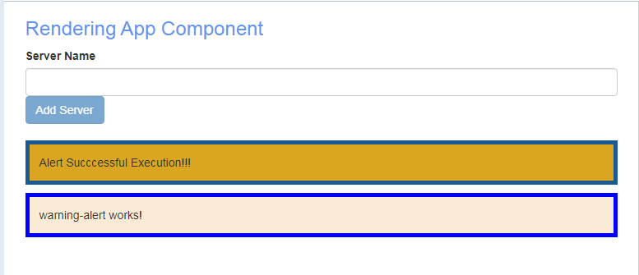

Output: After Event

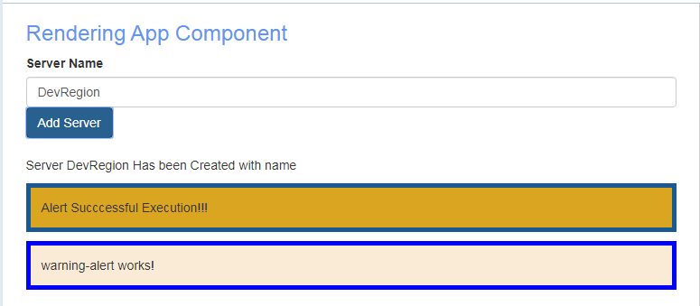

# Attribute Directive: ngStyle

Unlike the Structural the attribute directive does not add or remove elements. They are designed only to change the characteristic of an element to which they are associated to. For example, back ground colour of a paragraph element.

The below mentioned example illustrates the scenario wherein the server status is highlighted in green when the random number generator provides a number greater than 0.5 and in all other scenario the back-ground colour is yellow.

File: app.component.html

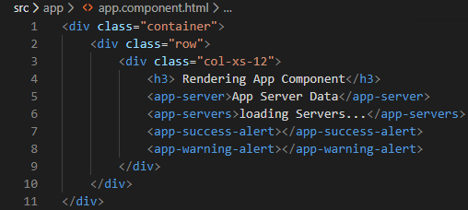

File: server.component.ts

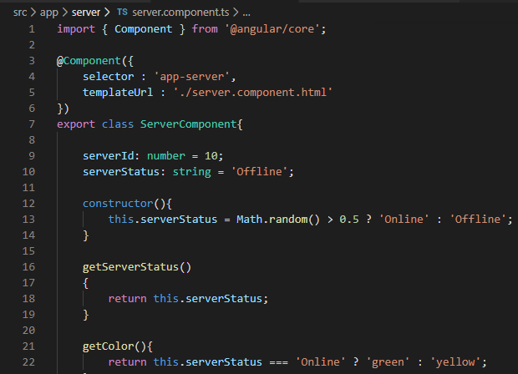

File: server.component.html



# Attribute Directive: ngClass

The directive is used to define identical styling across many HTML elements.

ngClass directive refers to the associated type script which contains the reference to styling definition either inline or in terms of an external CSS file.

The property binding syntax requires assignment of a key value pair to the attribute “ngClass”, where in the key attribute refers to the name of the CSS class and the value is a Boolean expression.

File: server.component.ts: The example provides the styling definition as a inline code.

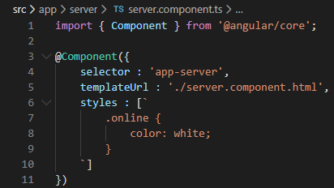

File: server.component.html

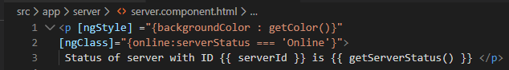

Output:

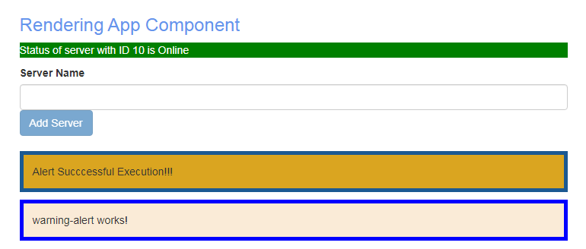

# Structural directive ngFor

It is a structural directive that is used to render a portion of HTML element once for every element in a traversable collection.

File: app.component.html

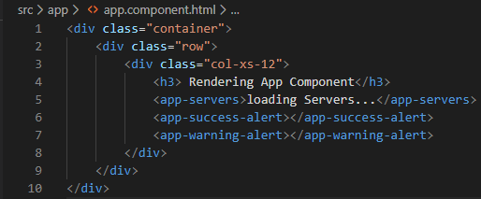

File: servers.compoenent.ts

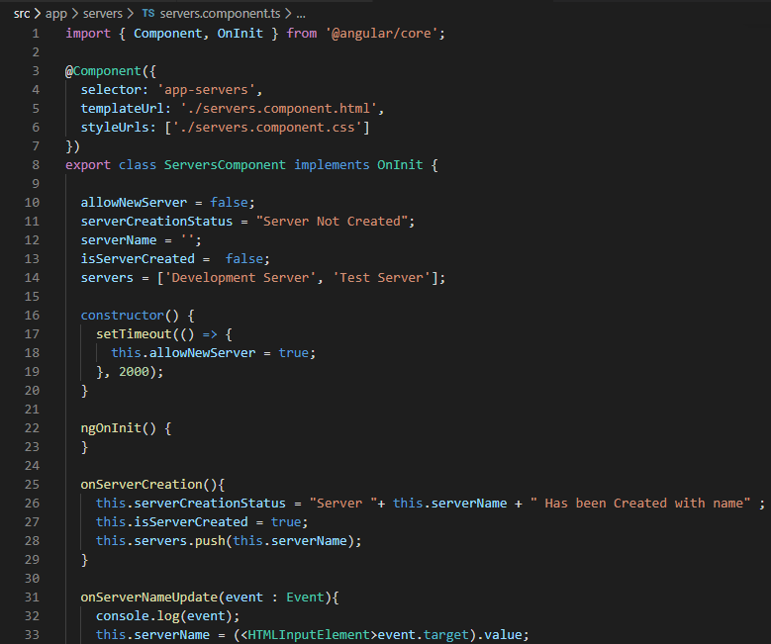

File: servers.component.html

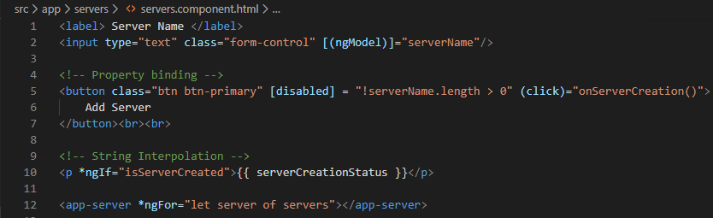

Output:

Before Event:

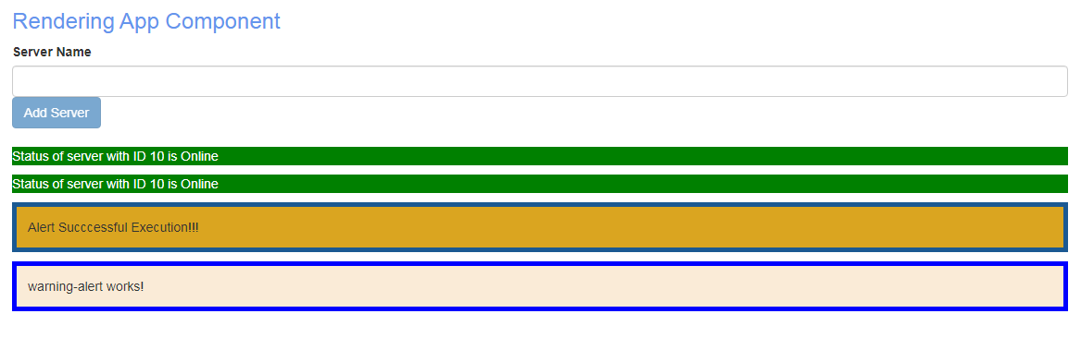

After Event:

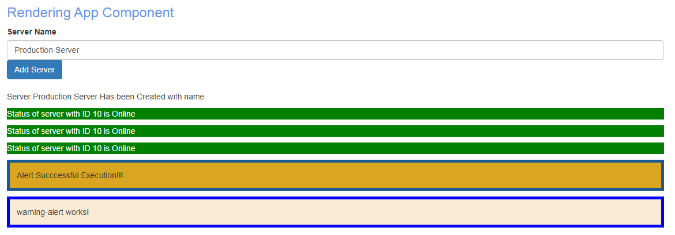

# Accessing index using ngFor

The present project will be modified with the following implementation to understand the working of index in conjunction with ngFor.

1. Implement a button to add Display details.
2. A paragraph to display predefined password in the event it is not rendered.
3. Logger to display timestamp every time the button is clicked
4. For all the clicks beyond 5th occurrence the background colour is to be initialized to blue and the font colour to white.

The solution to the 4th and 5th section is achieved by declaring an index variable I, the syntax is a reserved statement described as “let I = index”.

File: servers.component.html

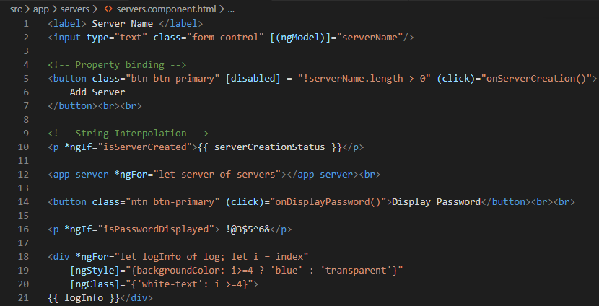

File: servers.component.ts

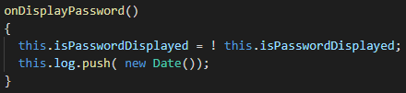

File: servers.component.css

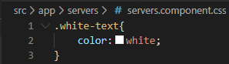

# Binding Custom properties

By default, the visibility of all the properties are confined to the housing component. In the event if a property is to be made visible to the parent component, The **@Input** decorator is used to achieve propagation of data from parent to child component.

The below example illustrates a scenario where in the property named as **element** which is contained in the “**server-element-component**” is enhanced with a wider visibility in order to allow data propagation from the parent component i.e. “app-component”.

File: app-component.html

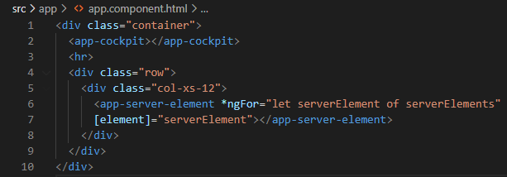

File: app-component.ts

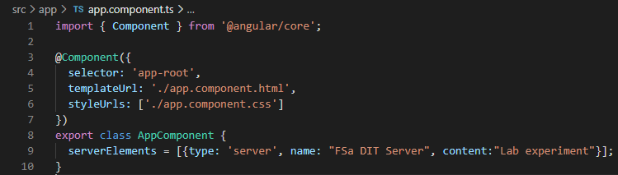

File: server-element-component.html

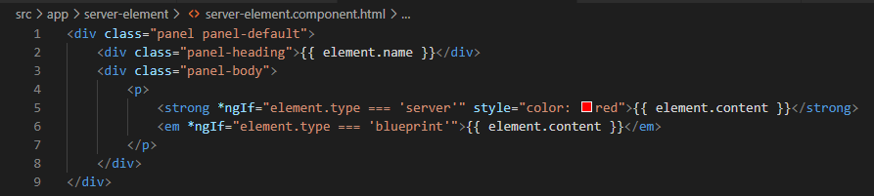

File: server-element-component.ts

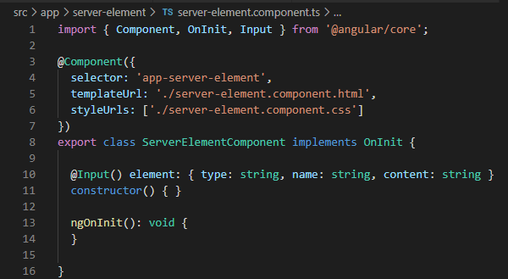

File: cockpit-component.html

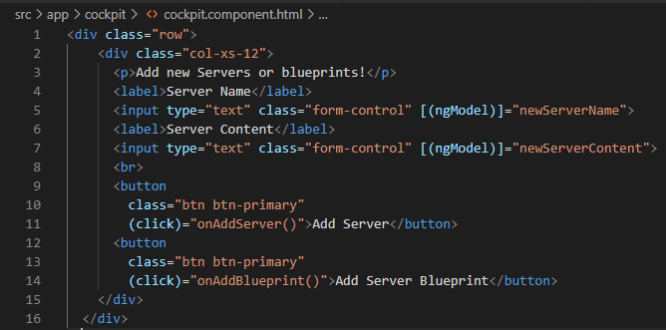

File: cockpit-component.ts

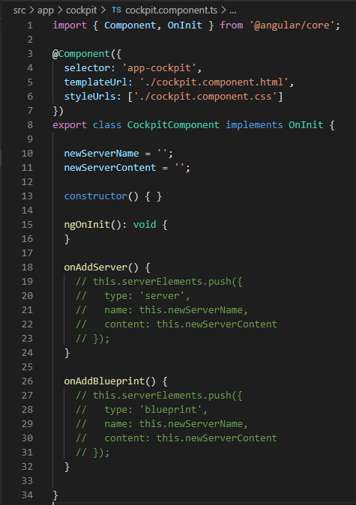

Output:

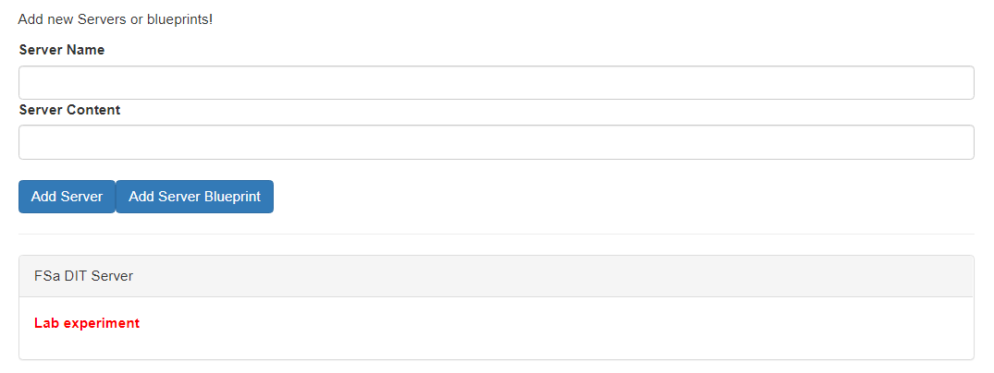

# Assigning alias to custom properties

The name of a property being accessed in the parent component is not required to be the same as what is defined in the child component. An alis can be defined to avoid any conflicts which can be defined as @Input(‘**AliasName**’).

File: app.component.html

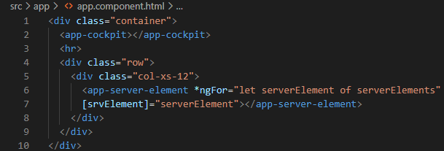

File: server-element.component.ts

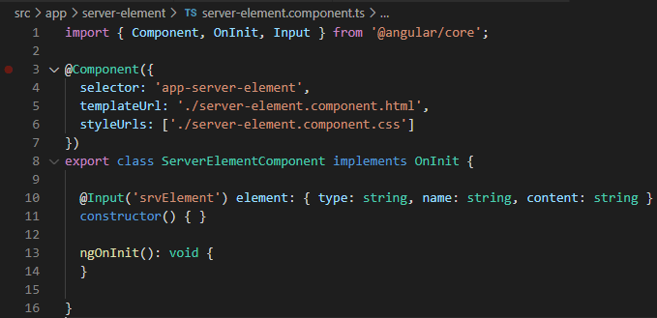

# Binding Custom Events

This section speaks of the implementation to propagate an **event** from the child component all the way to the parent component.

The trailing example demonstrates a scenario where in the **Add Server** and **Add Server Blue Print** event residing in the cockpit component is passed on to the app component upon its occurrence along with the event object that contains the form data.

Decorator @Output in conjunction with the from the angular core module is used to emit the data from the child component.

File: app.component.html

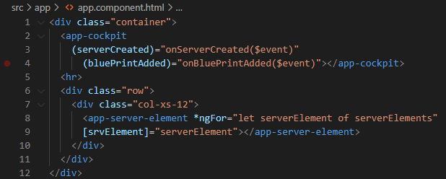

File: app.component.ts

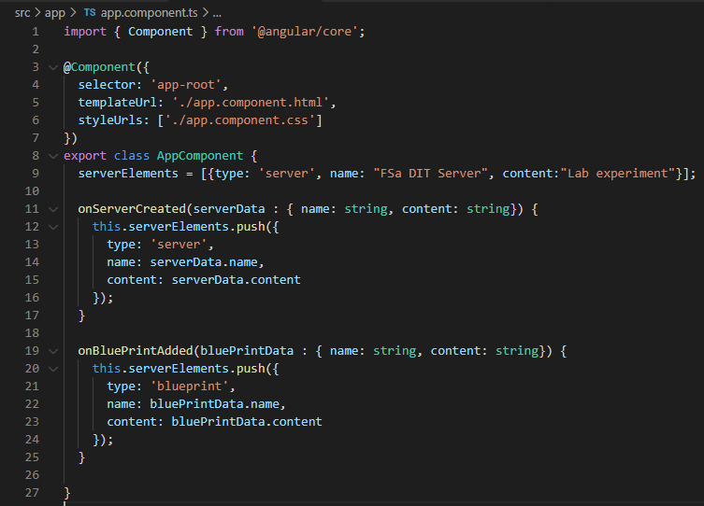

File: cockpit.component.html

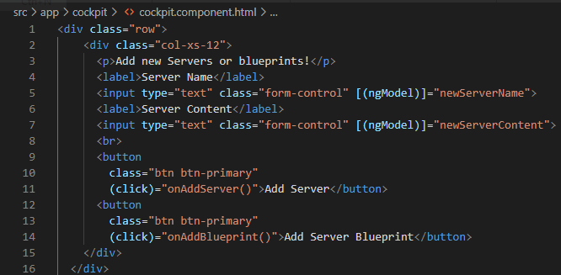

File: cockpit.component.ts

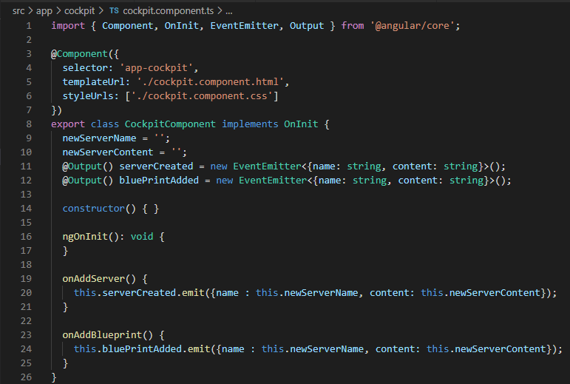

The @Output decorator can be embedded with an alias to which the external components can listen to.

File: app.component.html

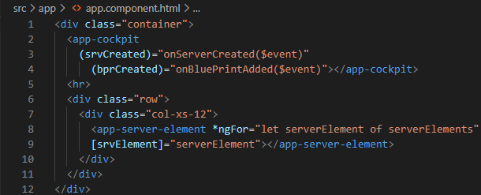

File: cockpit.component.html

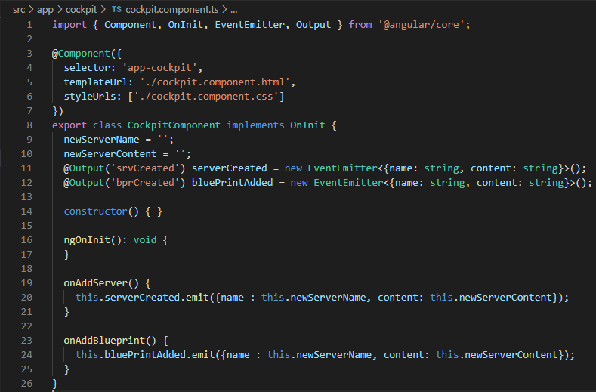

# View Encapsulation

Shadow DOM refers to the ability of the browser to include a subtree of DOM elements into the rendering of the document, but not into the Main document DOM tree.

Ref: [Shadow DOM](https://glazkov.com/2011/01/14/what-the-heck-is-shadow-dom/)

*View Encapsulation* Defines the templates and styles available for a component. Angular provides three different types of view encapsulation.

## Type 1: None

Upon changing the view encapsulation to “None” in app.component.ts file, the paragraph style defined in the “app.component.css” is applied to all the other child components as well. The examination of the source code in the browser reveals that the paragraph style has been declared in the head section of the DOM.

File: app.component.css

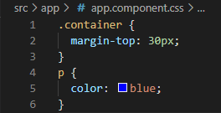

File: app.component.ts

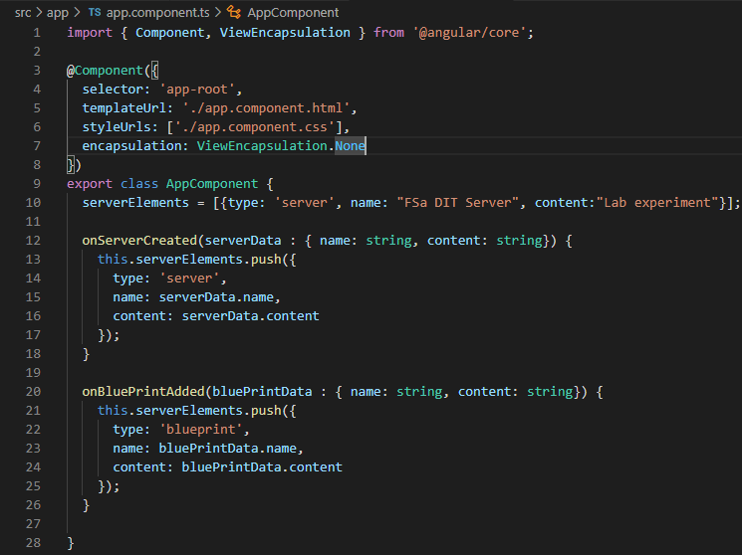

Browser Source Code:

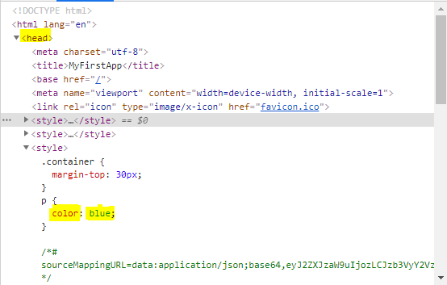

## Type 2: Emulated

In this case Angular will not create a shadow DOM, Style will be scoped to a particular component and this is the default value for encapsulation.

File 1: app.component.ts

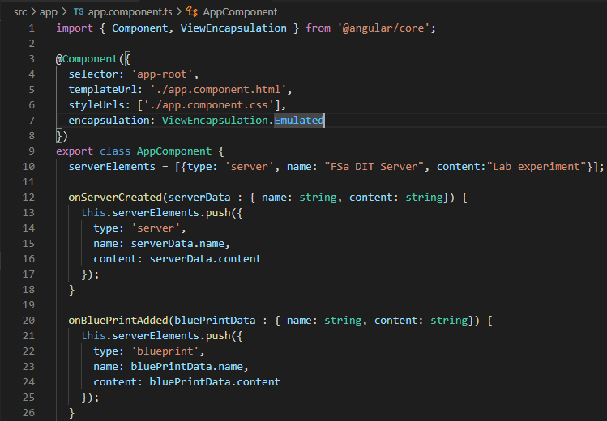

Browser Code inspection: the style is scoped to a particular component.

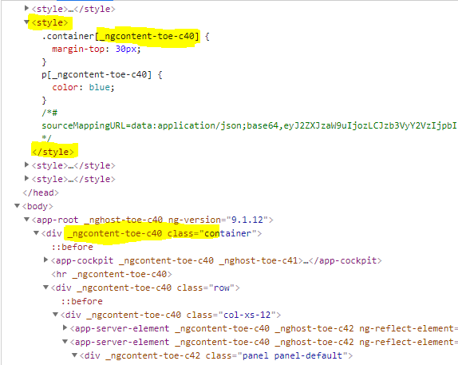

## Type 3: ShadowDom

This encapsulation uses browsers native shadow DOM implementation to attach a shadow DOM to the components host element and then puts the components view inside that shadow DOM. The components view is included within the shadow DOM.

# Using local reference in templates

It is an alternative to two-way binding by providing a local reference name on an element. In our earlier example on two-way binding the value of server name was associated to the type script using ng model. Which will be can be replaced with a local reference as follows.

File: cockpit.component.html

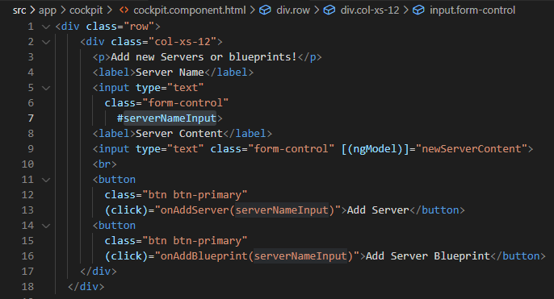

File: cockpit.component.ts

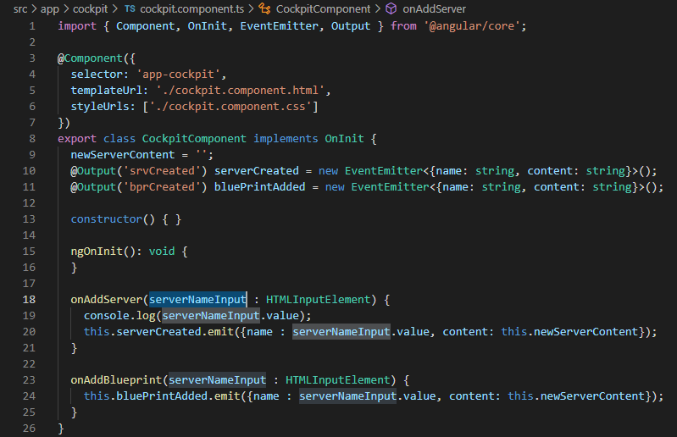

# Accessing Template and DOM through @ViewChild

This decorator provides a way to access and manipulate DOM elements, directives and components.

File: cockpit.component.html

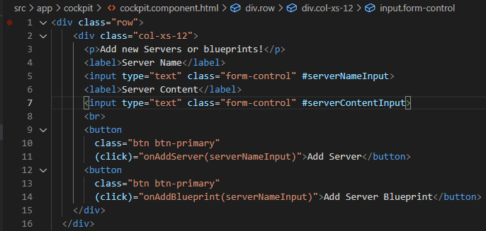

File: cockpit.component.ts

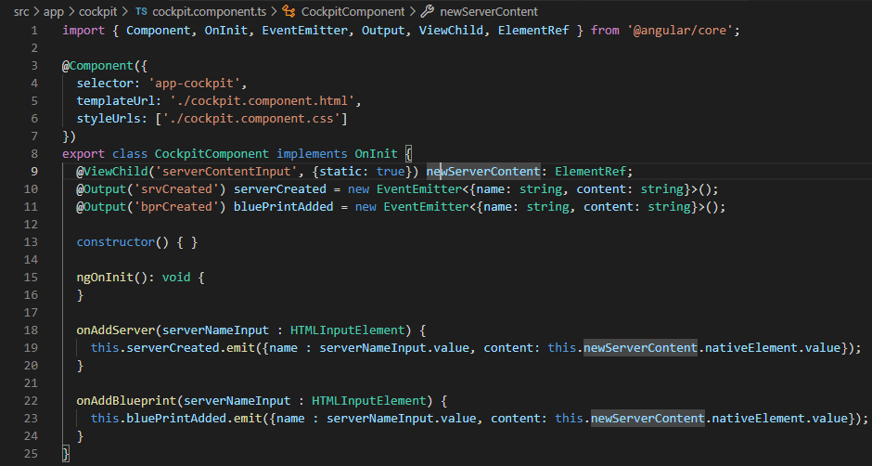

# Projecting content into components using ng - content

We use <ng-content></ng-content> tag as a place holder for the dynamic content. Which when parsed by angular, it would be replaced by the designated content.

The technical term for this would be content projection. Because this helps us to project the content from the parent component to the designated child component.

File: app.component.html

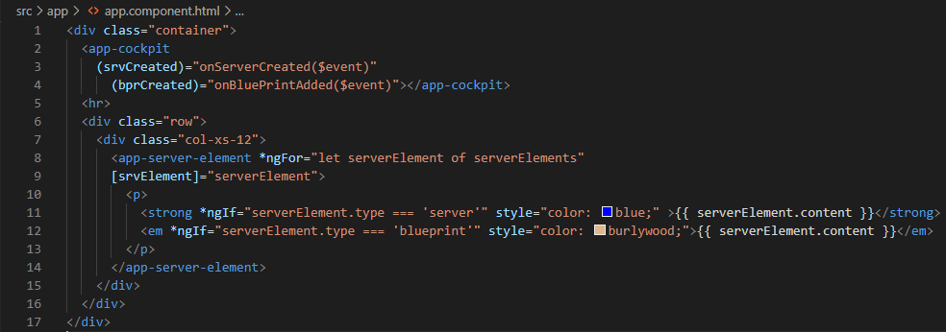

File: server-element.component.html

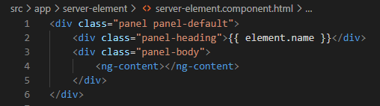

# Component lifecycle hooks

A component instance has a lifecycle that starts when angular instantiates the components class and renders the components view along with the child’s view. The lifecycle continues with change detection, as angular checks to see if the data bound properties change and updates both the view and the component instance as needed.

The lifecycle ends with angular destroying the component and removes its rendered template from DOM. Developers can respond to events in the life cycle of a component or directive by implementing one or more of the life cycle hooks in the Angular core library.

|  |  |  |
| --- | --- | --- |
| Hook Method | Purpose | Timing |
| ngOnChanges() | Respond when Angular change data bound input properties. The method receives a SimpleChanges object of current and the previous values.  Note: This event happens very frequently, any embedded operation would impact the performance significantly. | Called before ngOnInit() and whenever one or more data bound input properties changes. If you components has no output or use it without providing inputs, the framework will not call ngOnChanges() |
| ngOnInit() | Initialize the directive or component after Angular first displays the data bound properties and sets the directive or components input properties. | Called once after the first ngOnchange() |
| ngDocheck() | Detect and act on changes that Angular can’t or won’t detect on its own. | Called immediately after ngOnChanges() on every change detection run and also after ngOnInit() on the first run. |
| ngAfterContentInit() | Respond after Angular projects an external content into a component’s view or into the view a directive is in. | Called once after the ngDoCheck() |
| ngAfterContentChecked() | Responds after Angular check the content projected into a component or directive. | Called after every ngContentInit() and subsequent ngDoCheck() |
| ngAfterViewInit() | Respond after Angular initializes the components and child’s view or the view that contains the directive. | Called once after the ngAfterContentchecked(). |
| ngAfterViewChecked() | Respond after Angular checks the component and child’s view or the view that contains the directive. | Called after ngAfterViewInit() and every subsequent ngAfterContentChecked(). |
| ngOnDestroy() | Clean up just before angular destroys the directive or component. Unsubscribe observable and detach event handlers to avoid memory leaks. | Called immediately before angular destroys a directive or component. |

The following code snap shot illustrates the execution flow of all the life cycle hooks.

File: server-element.component.ts

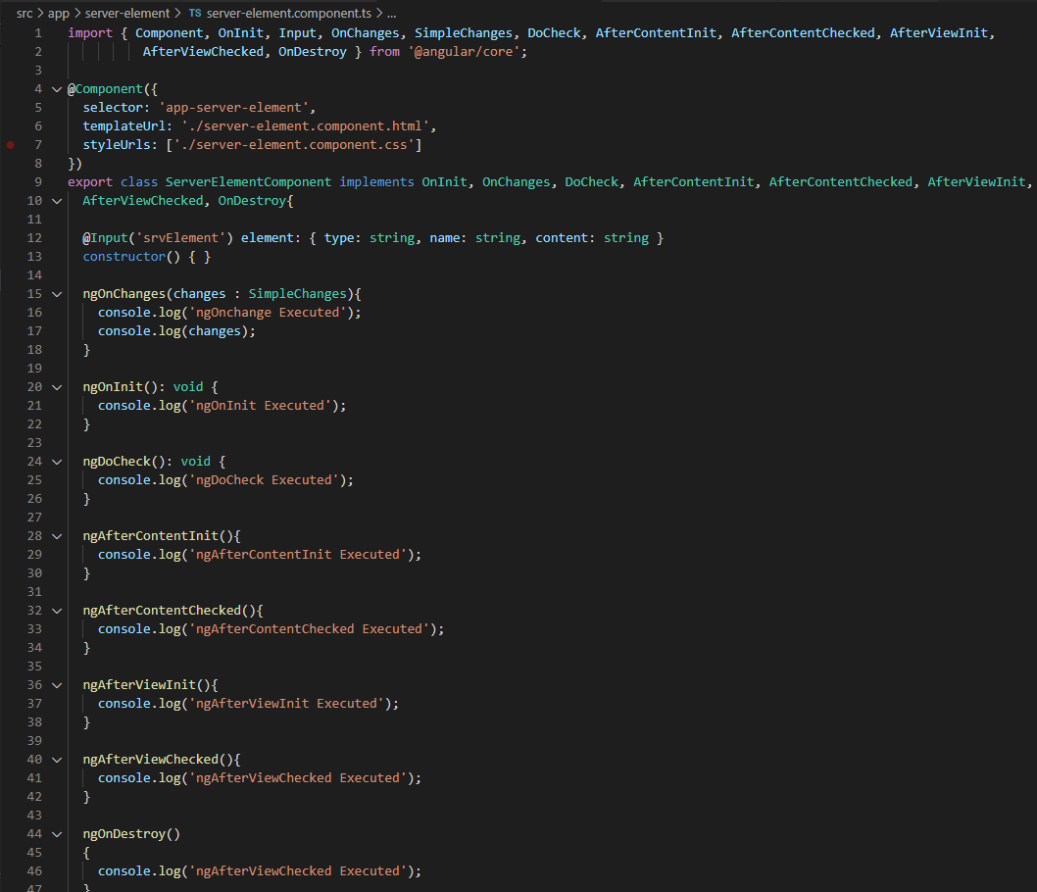

Browser Output: Before Event

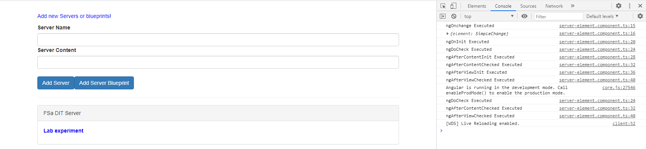

Browser Output: After Event

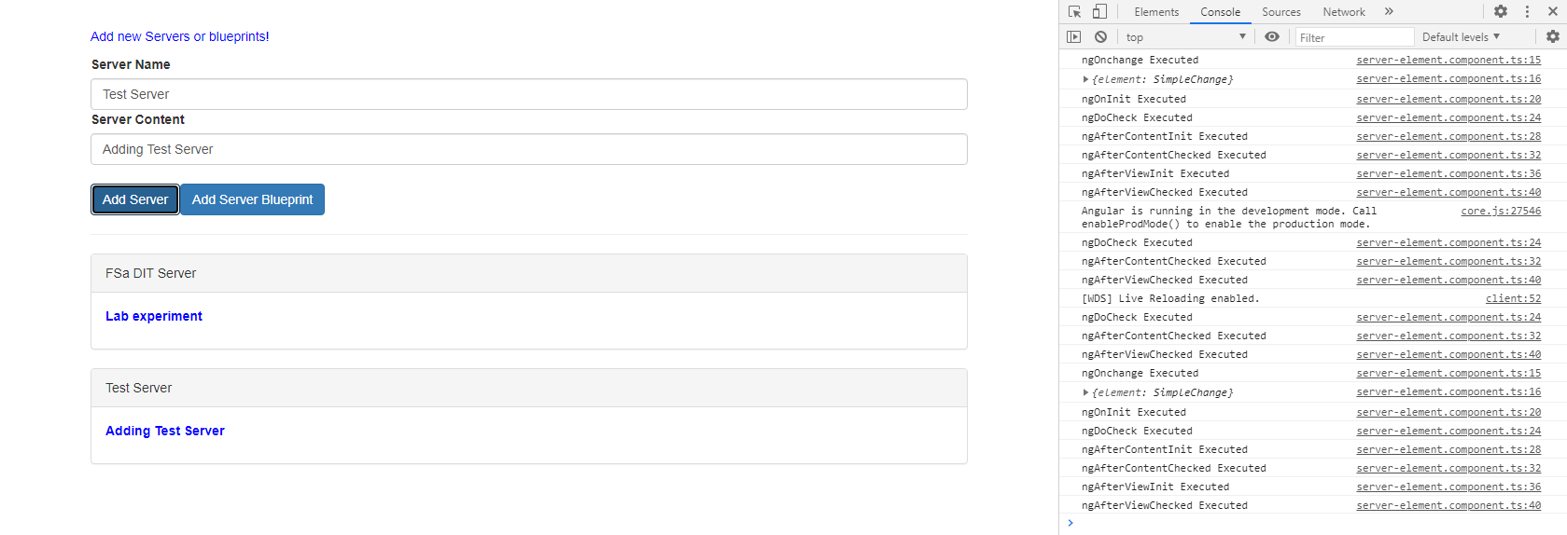

# Lifecycle hooks and template access

Until the view is initialized the access to any element would result in a null reference. Execution of ngAfterViewInit() happens right after the view is initialized. The logger within the ngOnInit() method prints a null value whereas the same logger renders data when enclosed within the ngAfterViewInit() method.

The following example illustrates the point in time when the access to a view results in a successful outcome.

File: server-element.component.ts

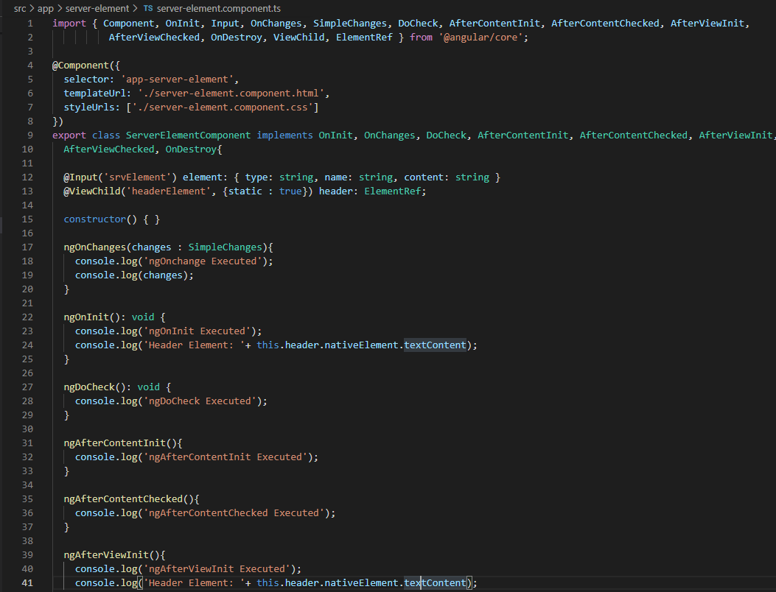

File: server-element.component.html

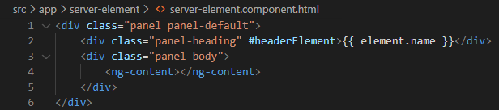

Browser Output:

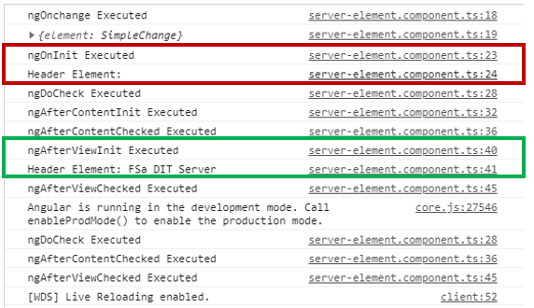

# Getting access to ngContent using @ContentChild

The paragraph tag in the app.component.html file is updated with the selector which will then be configured in the server-element.ts file in conjunction with the @ContentChild hook to render the information in the console logs. The output does render a successful information only after the content is initialized not during the initialization of the view.

File: app.component.html

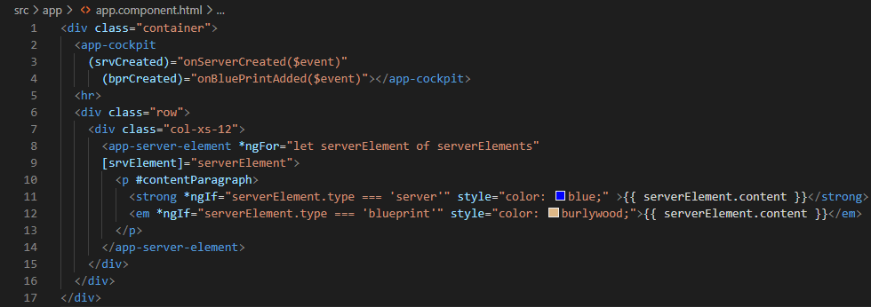

File: server-element.component.ts

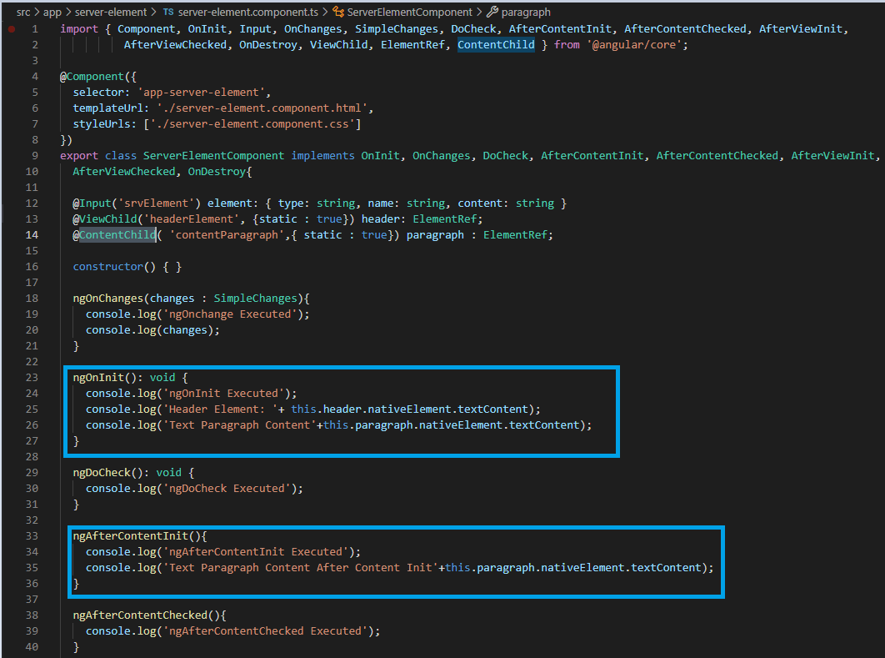

Output:

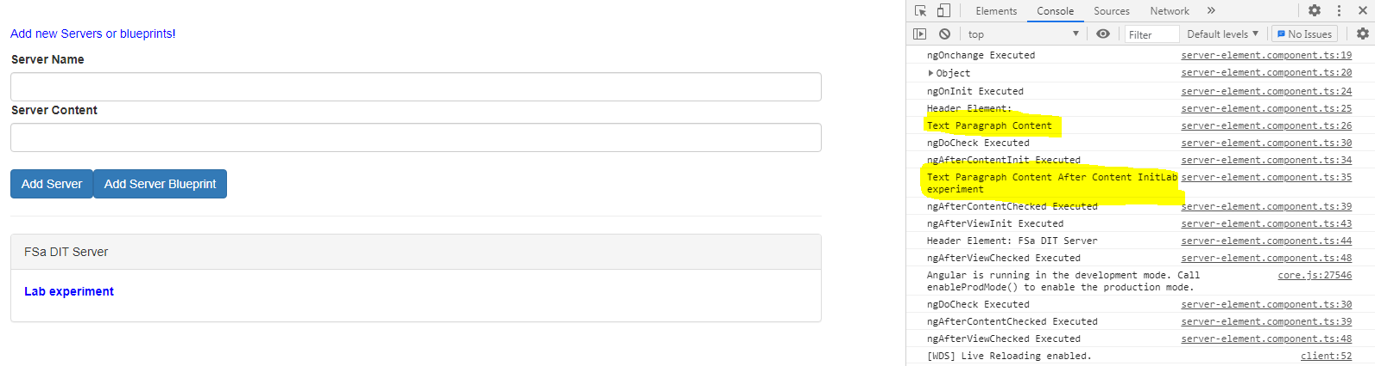

# Adding navigation with event binding and ngIf

In this topic we fall back to the Recipe Application, where in the present setup is enhanced with navigation capability with first selection rendering all the components relevant recipes and second selection the offers view of all the shopping list components.

On the implementation, the header.component.html file which contains the navigation tag will be updated with attributes to initiate a functional call on the occurrence of click event, the corresponding **header.component.ts** will have implementation to capture the string literal from the click event and initialize the value to an output event variable and emit the same to the parent component.

The app.component.html file that incorporates the header component, would undergo changes in the corresponding selector tags to binding of the event to a function call, the implementation of this function will initialize extract string literal from the event and initialize the value to a local variable.

Which is then used in conjunction with ngIf to define rules on when to enable view on a particular component.

File 1: header.component.html

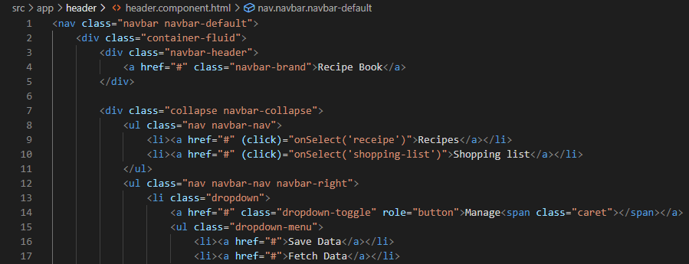

File 2: header.component.ts

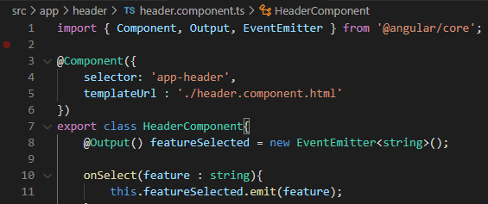

File 3: app.component.html

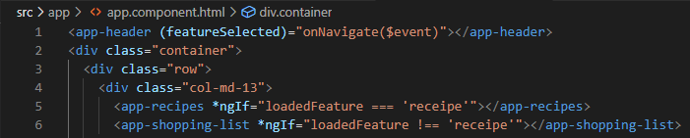

File 4: app.component.ts

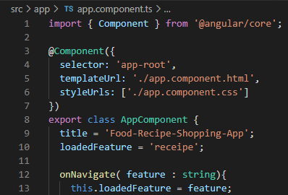

File 5: Recipe Section

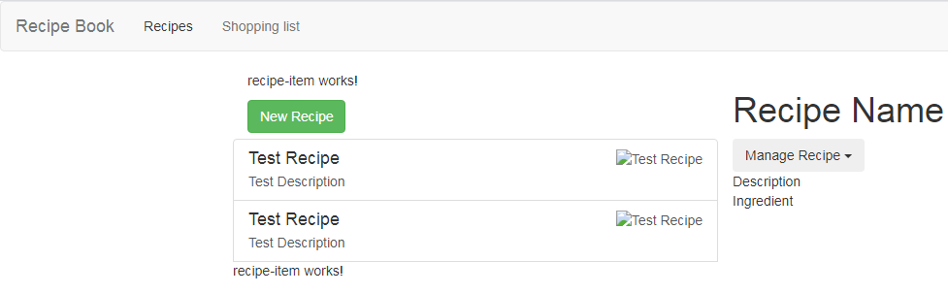

File 6: Shopping list Section

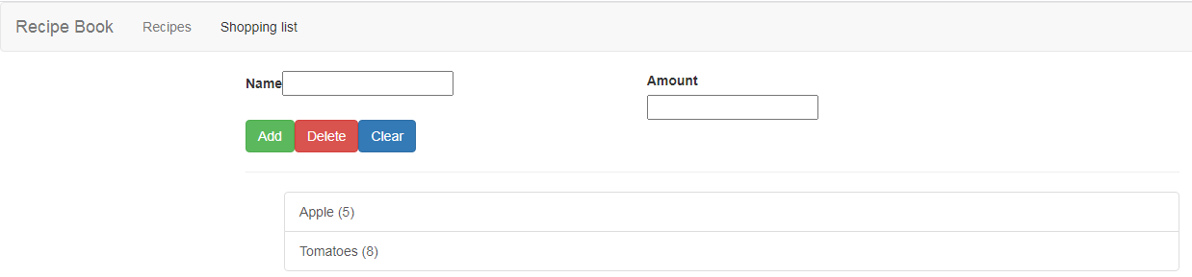

# Passing data with property binding

In the present application the recipe list html file holds implementation to iterate and initialize recipe item component which will be improvised to separate the logic of initializing from traversing.

In order to do so the traversal will continue to happen through ngFor within the “app-recipe-item” selector with an additional attribute to initialize the elements of the iteration to a property which is declared in the recipe-item.component.ts marked with @Input decorator.

The externalized input variable will then propagate the data to recipe-iten.component.html

File 1: recipe-list.component.html

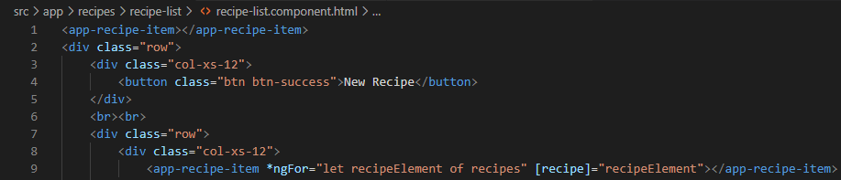

File 2: recipe-item.component.ts

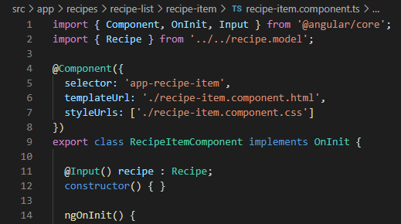

File 3: recipe-item.component.html

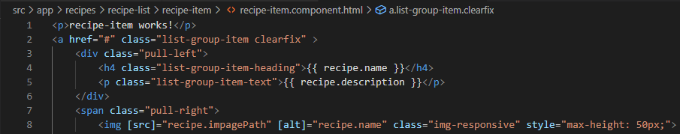

# Implementing Add functionality to shopping list

The intent of the assignment is to implement the add functionality to shopping list using local reference, @ViewChild and output event emitter.

File 1: shopping-edit.component.html

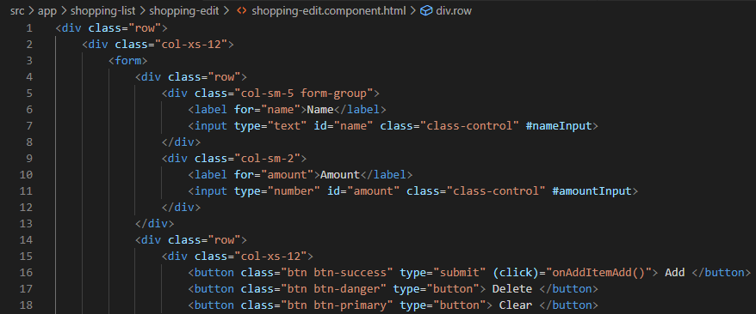

File 2: shopping-edit.component.ts

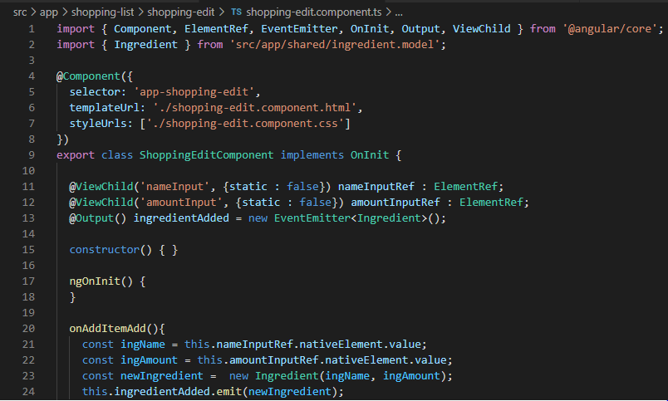

File 3: Shopping-list.component.html

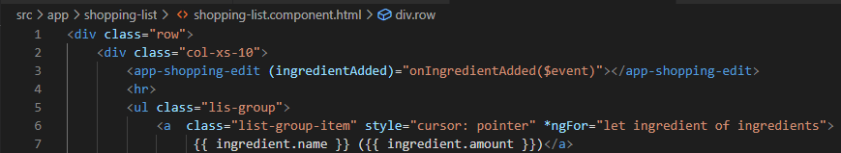

File 4: shopping-list.component.ts

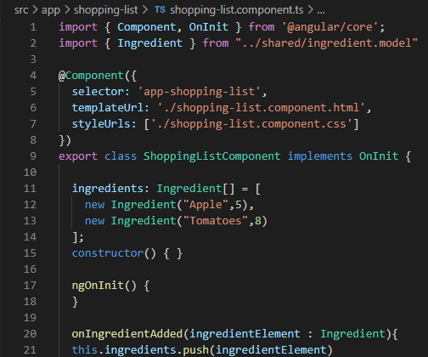

# Passing data with Event and property binding

The exercise would involve rendering the selected recipe in the recipe detail component. In order to do so, upon selecting a recipe an event needs to be propagated from the sub component root component. The following will be the order of propagation.

*recipe-item.component -> recipe-list.component -> recipes.component -> recipe-detail.component*

it can also be noted that the event from recipe item component to recipe list would have a null event as the parent component is already in possession of the recipe being selected within the ngfor traversal.

The usage of ngIf initializes the recipe detail component with a default text, if none of the recipe is selected and the default text is enclosed within the ng-template tag with local reference as identifier.

File 1: recipe-item.component.html

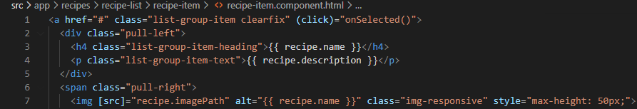

File 2: recipe-item.component.ts

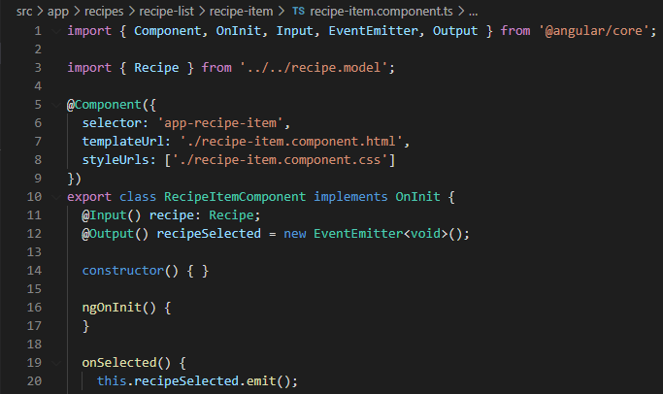

File 3: recipe-list.component.html

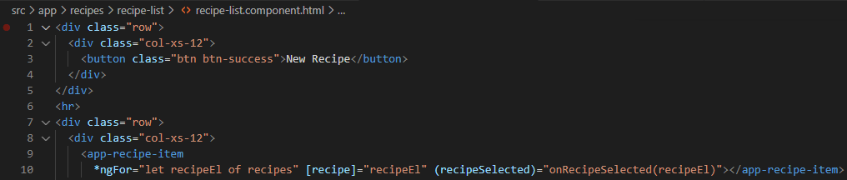

File 4: recipe-list.component.ts

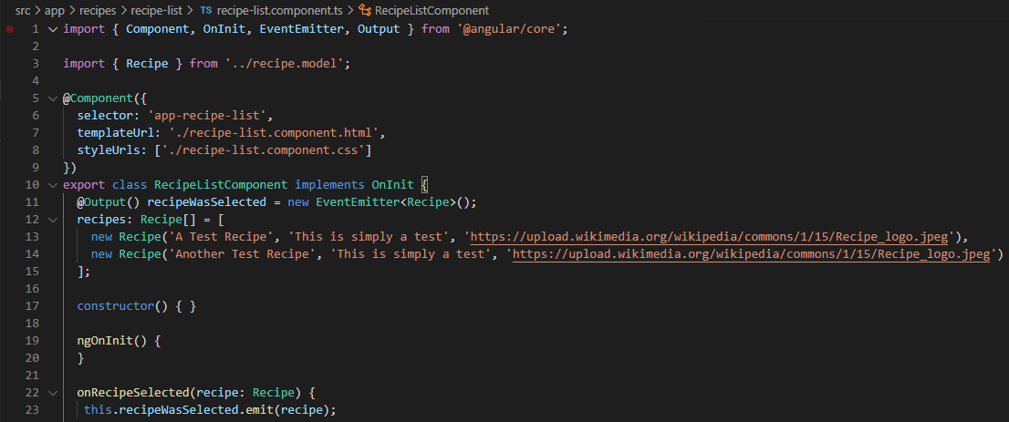

File 5: recipe-component.html

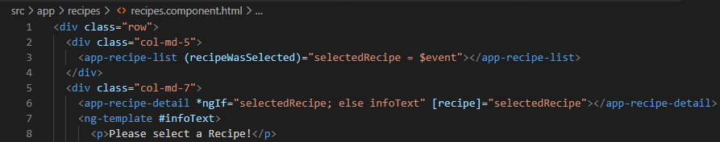

File 6: recipe.component.ts

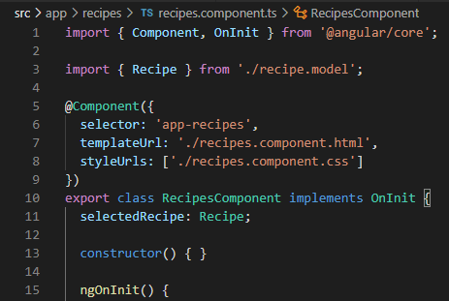

File 7: recipe-detail.component.html

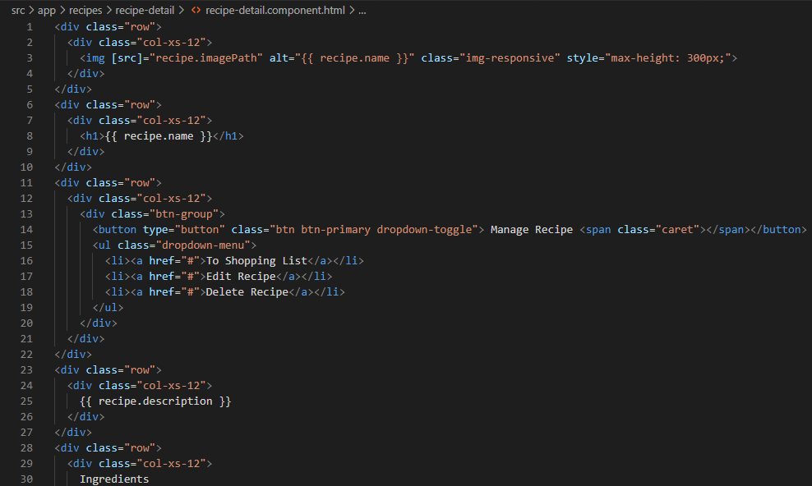

File 8: recipe-detail.component.ts

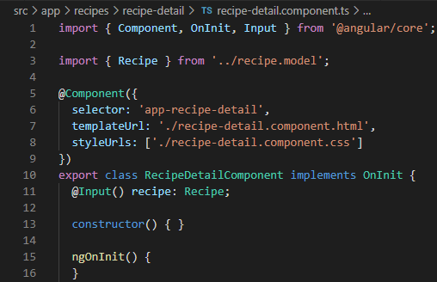

# Attribute VS Structural directive

|  |  |
| --- | --- |
| Attribute | Structural |
| Looks like a normal HTML attribute [possibly with data or event binding] | Looks like a normal HTML attribute but has a leading * |
| Only affect or change the element they are added to | Affects the whole area in the DOM [element gets added / removed] |
| Examples: ngClass and ngStyle | Examples: ngFor and ngIf |

# Creating a basic attribute directive

The first step towards creating an attribute directive starts with a type script file incorporating the selector and the styling to be associated to the directive.

Once the implementation is completed, the app module declaration will be updated with the availability of the new directive as there would not be an implicit scan on the underlying modules.

Note: The selector literal is enclosed within square brackets where as the usage of the selector does not require the brackets.

File 1: basic-highlight.directive.ts

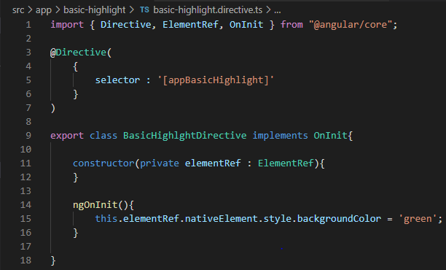

File 2: app.module.ts

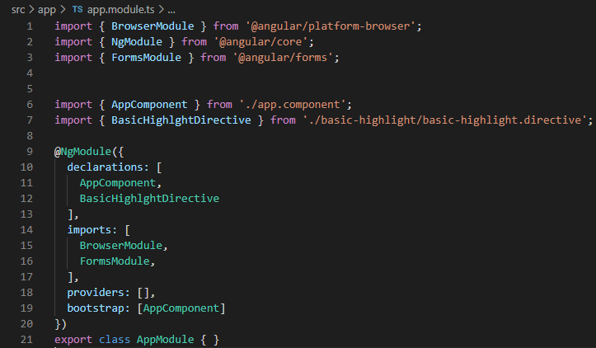

File 3: app.component.html

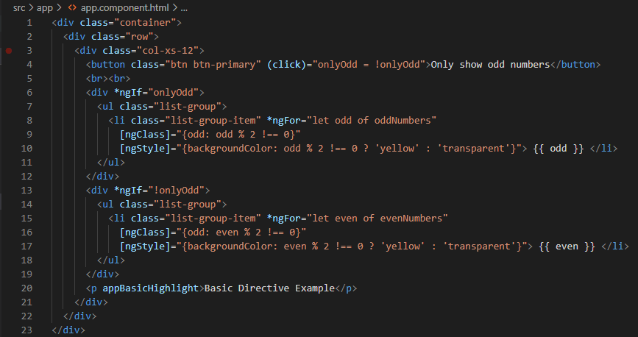

File 4: app.component.ts

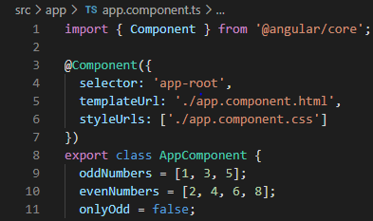

File 5: app.component.css

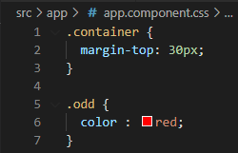

# Building attribute directive using renderer

The ideal way of accessing any element and also to modify its styling features would be through renderer. In order to access an element through renderer, the constructor contained in the attribute directive class will be added with a new parameter of type named “renderer” in addition to the element reference object.

Which will then be used to access the element and change the associated style as required.

File 1: better-highlight.directive.ts

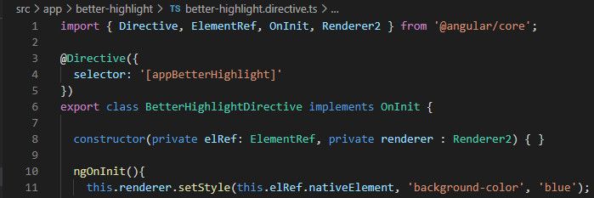

File 2: app.module.ts

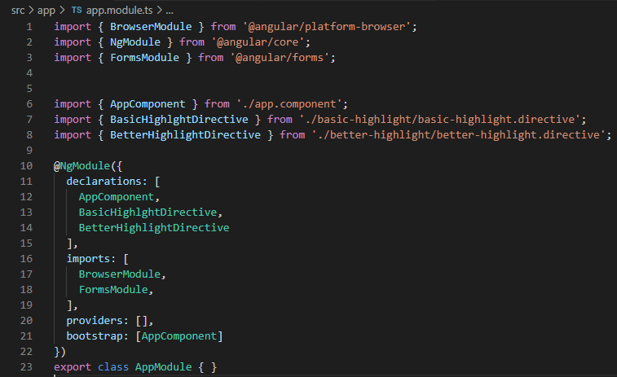

File 3: app.component.html

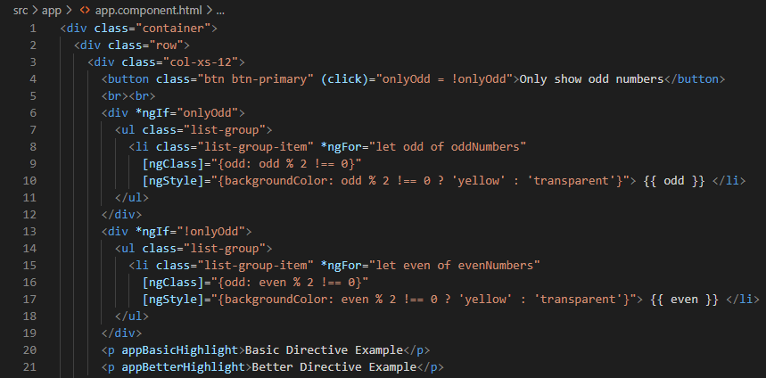

# Using Host listeners to capture events

In this example we will implement a listener to change the colour of an element when we have a mouse hover and mouse leave event using @HostListener attribute which takes in default event type “mouseenter” and “mouseleave”.

File 1: better-highlight.dierctive.ts

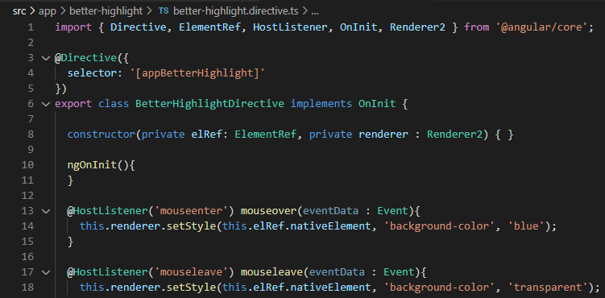

# Using Host binding to access properties of an element

The @HostBinding decorator allows you to set properties of the host element from the directives class.

Let’s consider the example of binding style properties such as back ground colour.

Suggested Reading: Difference between using renderer and host binding.

File 1: better-highlight.directives.ts

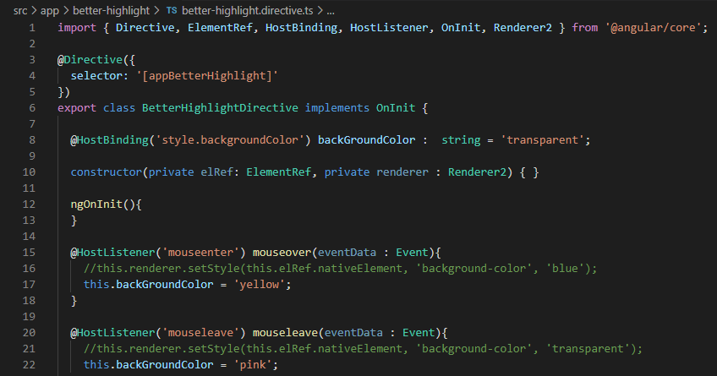

# Binding to directive properties

The following sections speaks about binding properties of a directive, lets consider the former example where in the background colour was initialized in the directive class, in the event if we want to make the choice of colour more configurable, the option would be to go for property binding through @Input decorator.

File 1: better-highlight.directive.ts

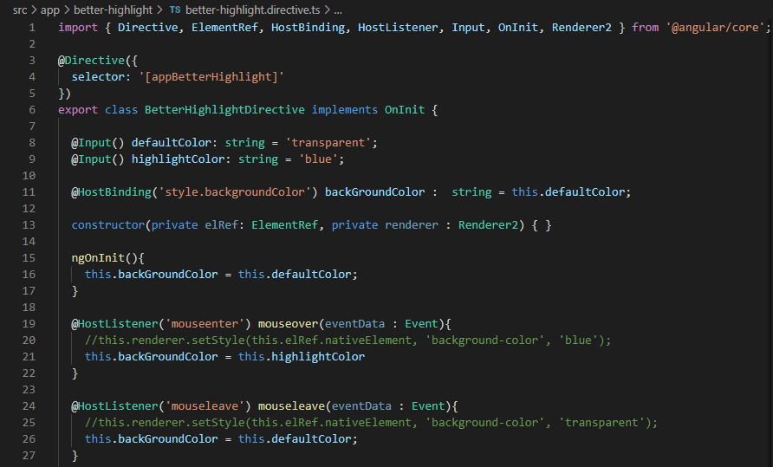

File 2: app.component.html

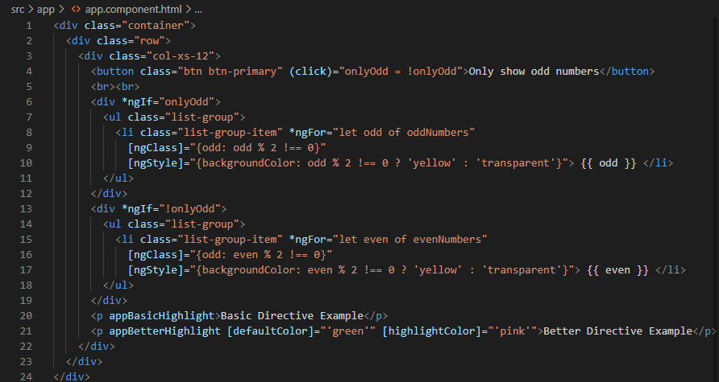

An extension to the above-mentioned setup is to use the directive name itself as an alias to the property. But the choice is made only if there is a single property that would be initialized as part of the setup.

The implementation would require an alias to be added as an attribute to the @Input decorator and the app component html file will under go change to initialize the value directly to the directive name which will be enclosed within square brackets.

File 1: better-highlight.diretcive.ts

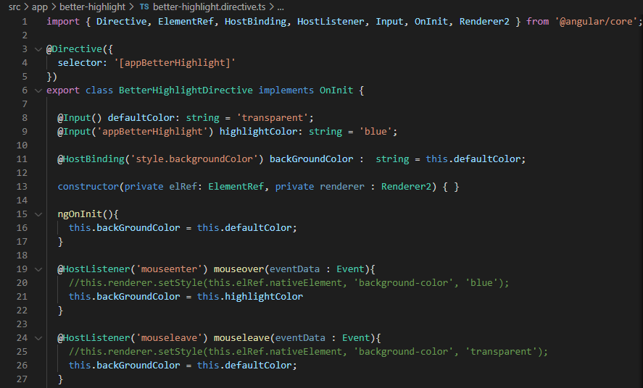

File 2: app.component.html

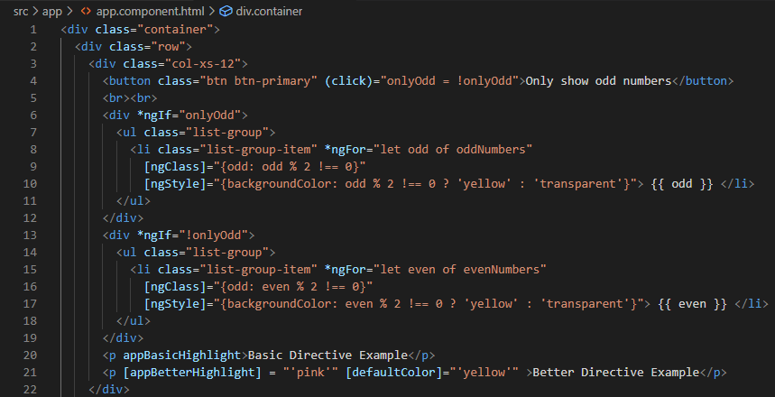

# Behind the scenes of a structural directive

All the Structural directives are prefixed with “*” symbol for angular to determine its significance. As an alternative we can user ng-template to enclose the structural directive without providing the “*” symbol as prefix.

File 1: app.component.html

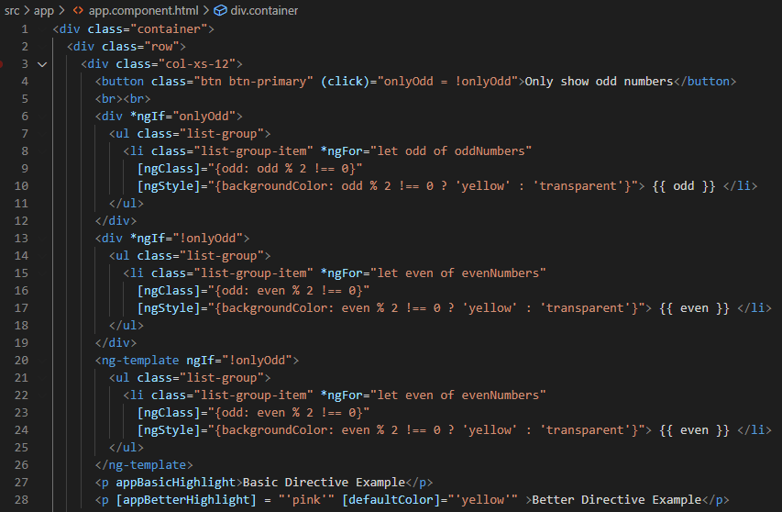

Output: Prior to change

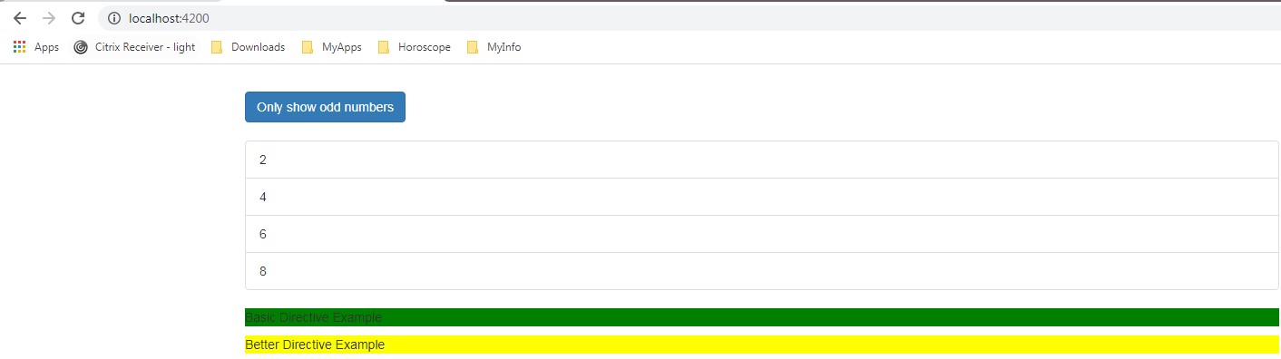

Output: Prior to change: Upon selecting “Only Show odd number”

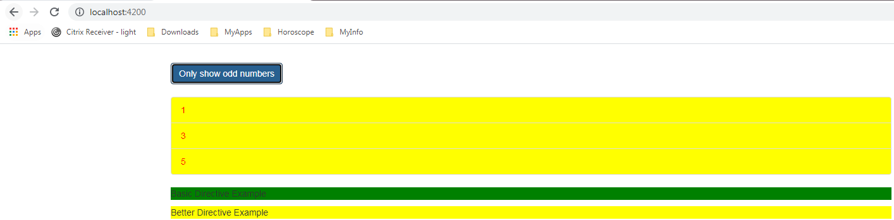

Output: After change to code base

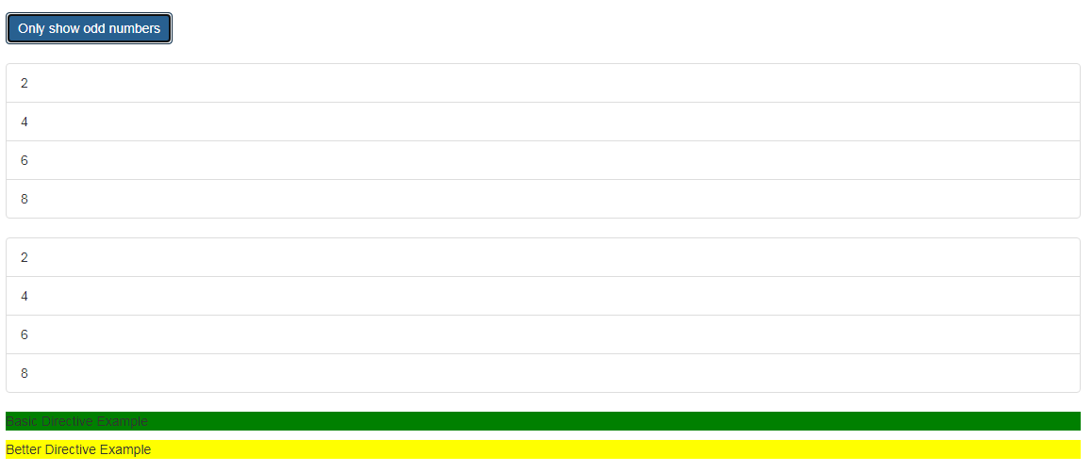

# Creating custom structural directive

In the following example we will create a new structural directive name “appUnless” which exhibits the functionality opposite to *ngIf. That is the structural directive renders a content only the evaluation results in false outcome.

The structural directive is created through the CLI command: ng g d unless

Next step would be to extract the condition as an input, for which we would create a property of similar type and as the condition changes we would want to execute a method which can be accomplished with the keyword set which translates to setter.

Even though having the prefix “set” to any variable would require suffix of “()”, the syntax would provide perspective of a method. But in reality, it is just a setter method for the property which gets executed whenever the associated value changes. Furthermore, the setter would have argument to receive Boolean value for evaluation followed by the implementation.

Now we would need access to the template and the position within the Dom where the structural directive should render the content. Both of these are made available by two variables as arguments into the constructor of the directive class, where the first argument is of type Template Ref and the second being View container reference.

File 1: app.module.ts

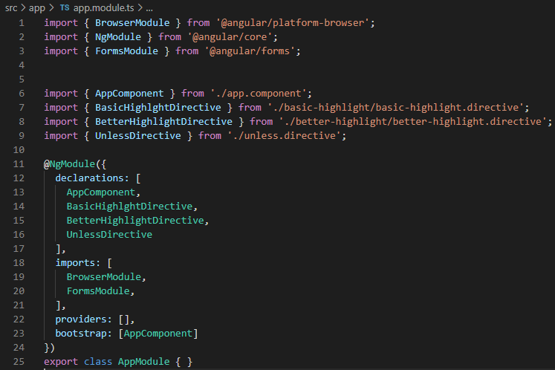

File 2: unless.directive.ts

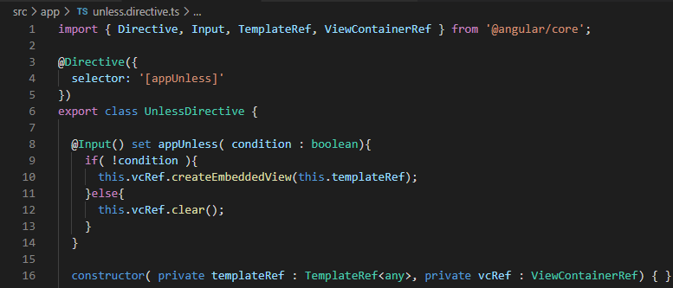

Fil3: app.component.html

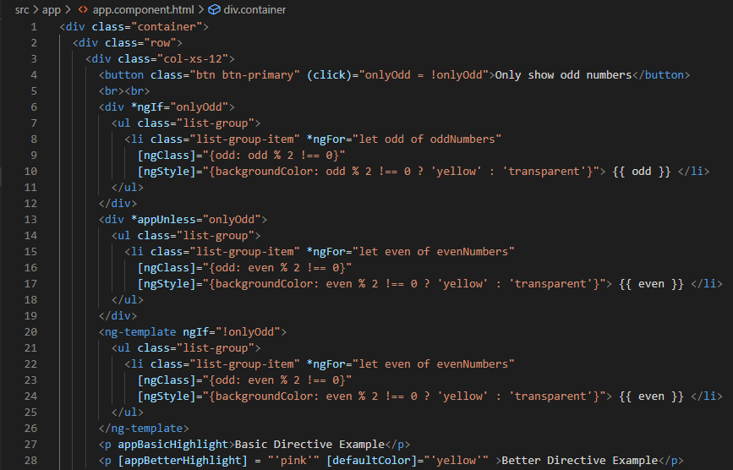

# ngSwitch Structural directive

The directive can be used as an alternative to ngIf where in the conditional evaluation is more in numbers.

File 1: app.component.ts

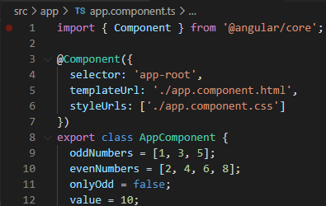

File2: app.component.html

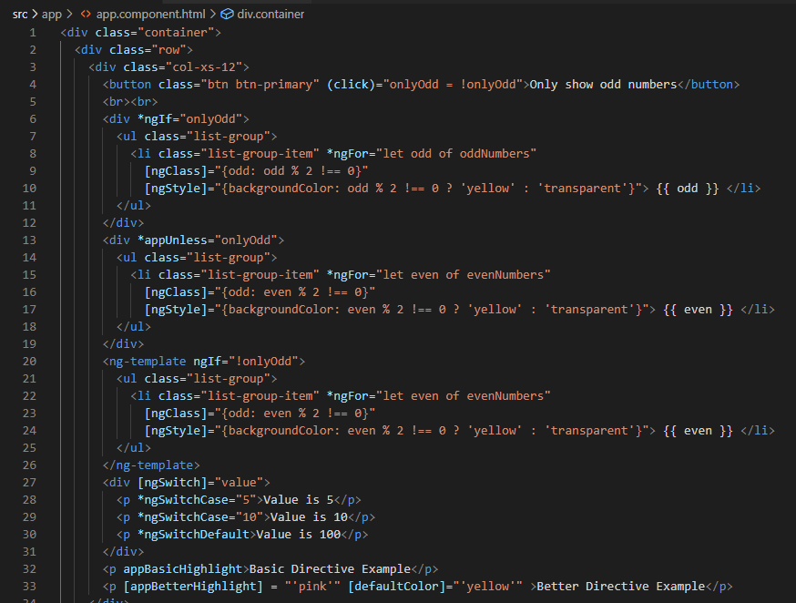

Output:

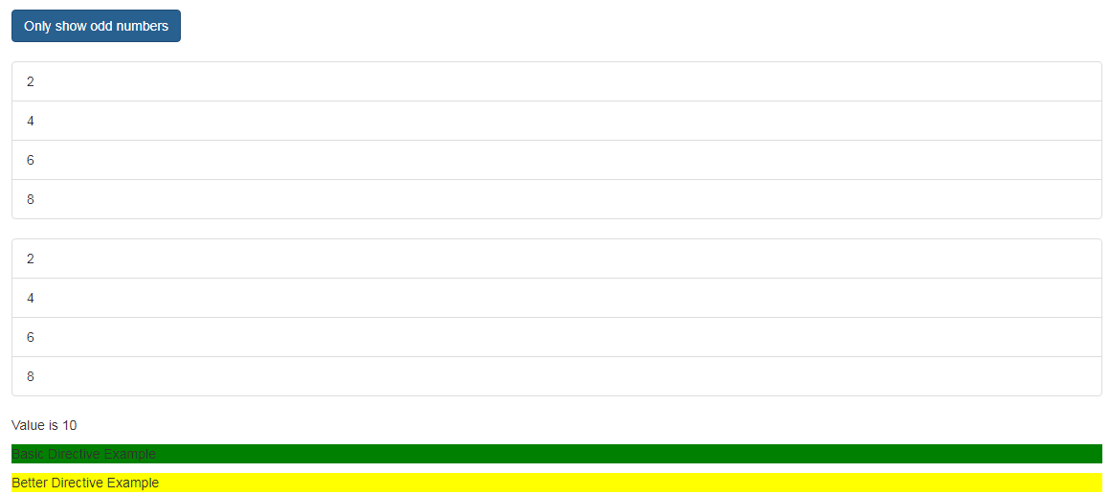

# Working on custom attribute directive

Switching back to recipe project, in the present application when any of the item in the recipe is selected and a click event on the associated “Manage Recipe” option does not list the drop-down menu and the same behaviour can be observed on “Manage” option on the top right corner.

The intent of the present section is to enable drop down menu on the afore mentioned tags.

Predefined class “open” incorporates the functionality to list the drop-down menu, the value to enable or disable the class will be propagated through host binding which will in turn be associated to a click event on an element through host listener.

File 1: dropdown.recipe.ts

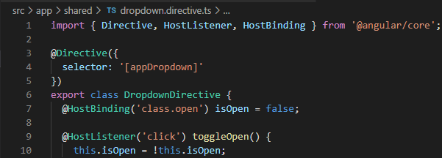

File 2: header.component.html

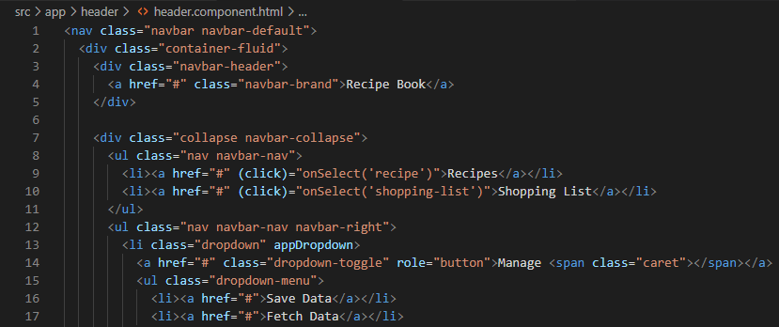

File 3: recipe-detail.component.html

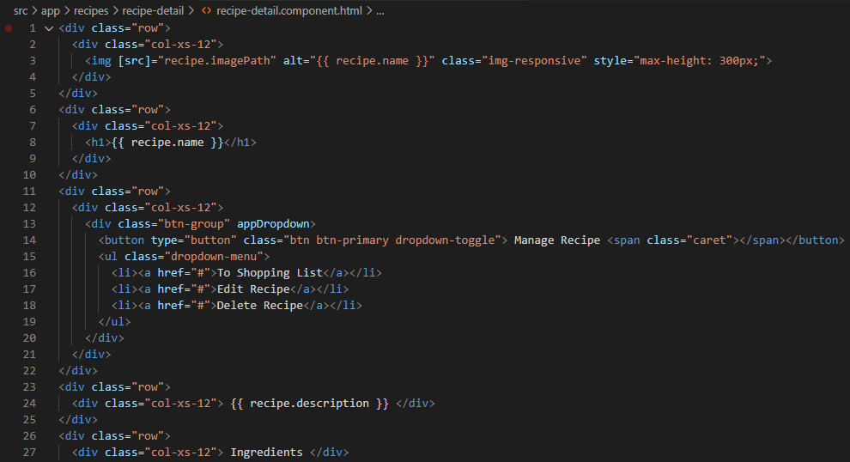

As an enhancement to the above-mentioned functionality, the drop-down directive type script file will be updated to close the drop-down menu on a click event anywhere in the document.

File 1: dropdown.directive.ts

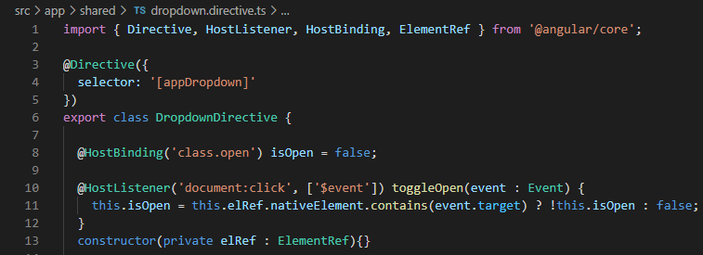

# Service and Dependency injection

A service is a class with narrow and well-defined purpose that fits the need across multiple components.

Using a service inside any class is not accomplished through instantiation of the object by means of new operator rather it is done through Angular dependency injector similar to the way all other objects are created.

The following are the steps required to inject an instance into any class.

Step 1: Create a parameterized constructor with an argument of the required service type.

Step 2: Within the @Component decorator add a new property named “provider” the initialize the value to required service.

File 1: app.module.ts

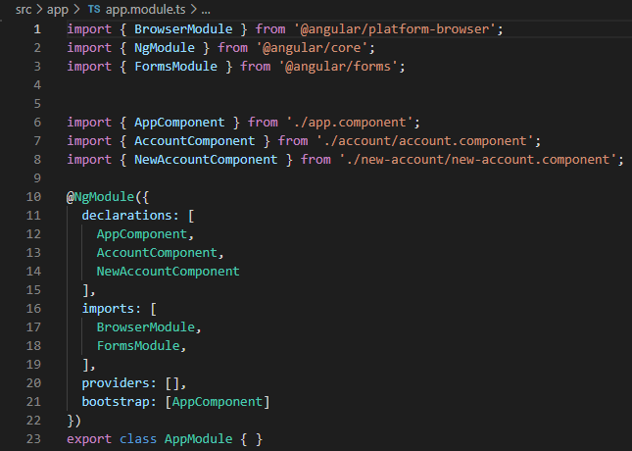

File 2: app.component.html

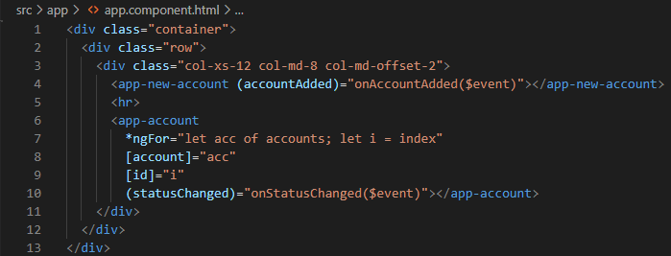

File 3: app.component.ts

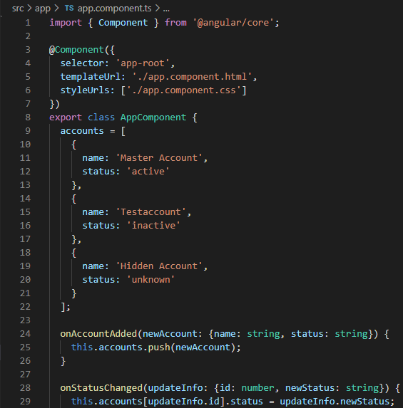

File 4: app.component.html

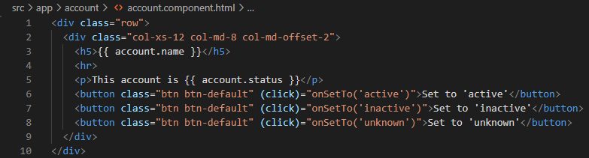

File 5: app.component.ts

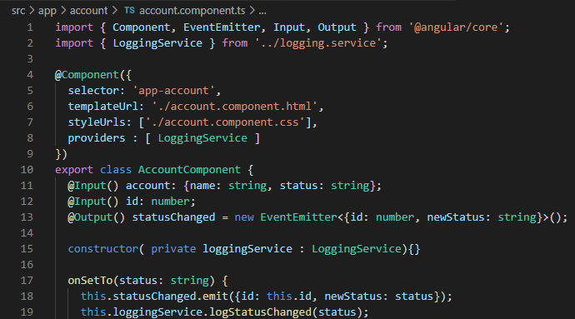

File 6: new-app.component.html

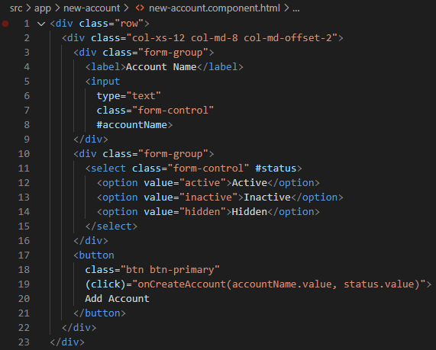

File 7: new-app.component.ts

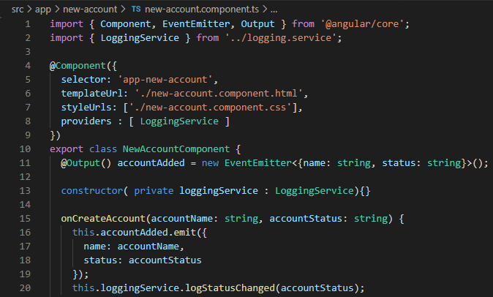

File 8: logging.service.ts

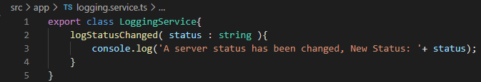

# Creating Data services and Hierarchical Injector

Angular dependency injector works on a hierarchical fashion. Such that a service instance in parent component is shared across all the child components. The following are the various hierarchy where a service can be provided and shared.

1. **App Module**: Same instance of the service is available application wide.
2. **App Component**: Same instance of the service is available across all the component.
3. **Any Other Component**: Same instance of the service is available for the component and all its child components.

In the following example we will create a new data service that holds the implementation to have an array of accounts and also means to manipulate the array to add new element and update the status of an existing element.

Although we rely on Angular to inject the service across all the component, we would want the same instance of the service account across App component.

In order to do that, avoid having provider property in the @Component decorator. There by instructing Angular to refer to the service instance created in the parent component.

File 1: accounts.service.ts

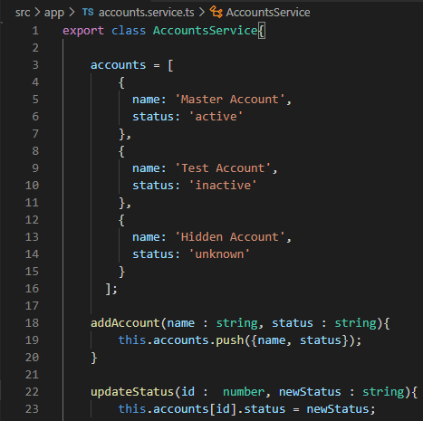

File 2: app.component.ts

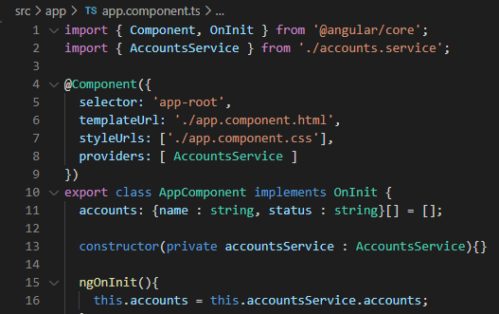

File 3: new-account.component.ts

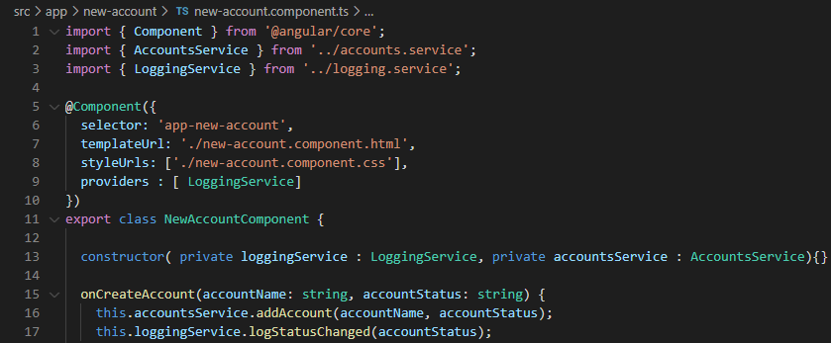

File 4: account.component.ts

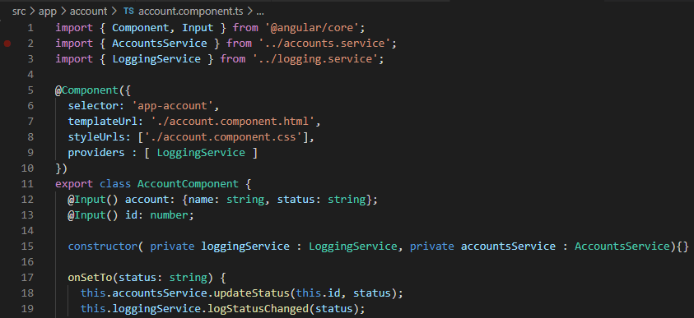

# Injecting one service into another

Given the fact that we have centralized the accounts manipulation logic into one single service, the logging can also be structured in a similar fashion. The only possible way of stream lining the logging statements is by placing them within the data services.

In order to place the logging within the data service, the logging service needs to be instantiated at the app module level increasing its scope to the entire application and also the Data service class should be enhanced with meta data stating that the class has an injectable property through @Injectable decorator.

File 1: app.module.ts

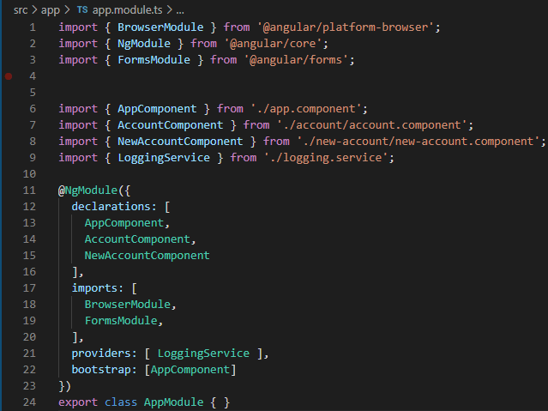

File 2: accounts.service.ts

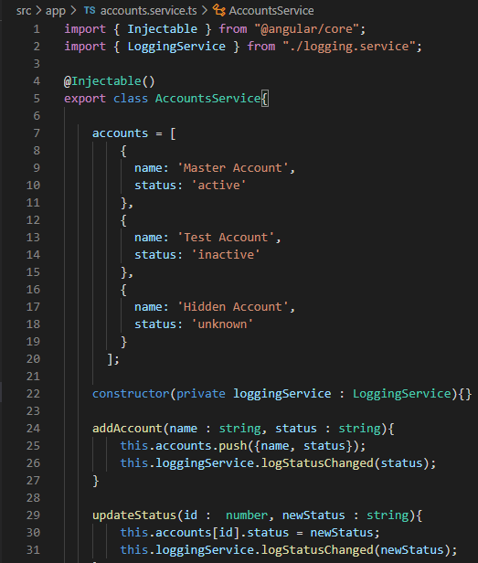

File 3: new-account.component.ts

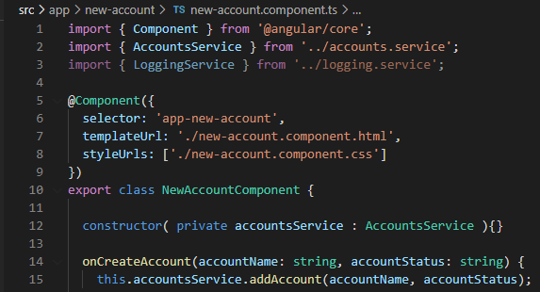

File 4: account.component.ts

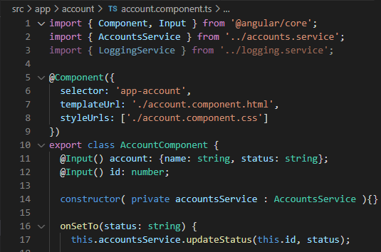

File 5: app.component.html

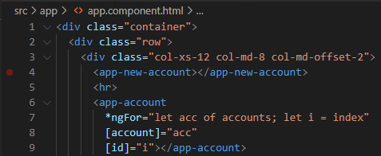

# Using Service for cross component communication

In order to pass any event between child components, the present approach relies on emitting an event to the parent and then once again redirecting the event through property binding to the other child event.

The approach can be refactored to event emitters and subscriptions through service. In the following example we would propagate a status change event between the child components – account and new account, without going through the parent component.

First, we would create a property of type event emitter in the Accounts service class followed by the Account component will emit a status changed event which will be subscribed by the new account component.

The status changed event will be captured by the new account component and will generate an alert on the screen with appropriate message.

File: accounts.service.ts

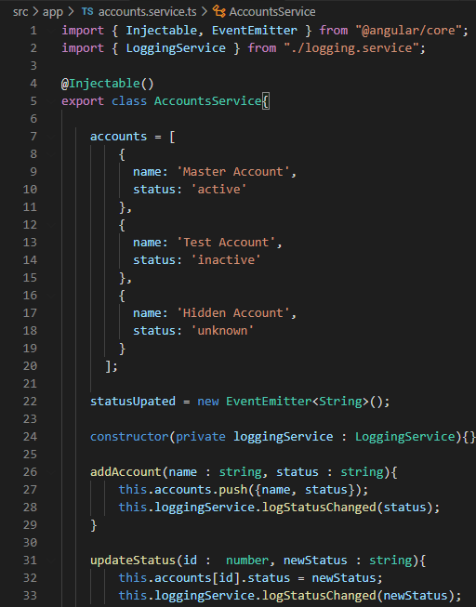

File 2: account.component.ts

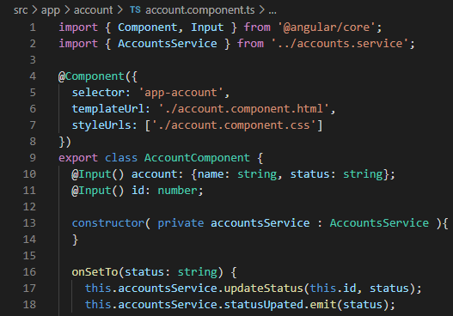

File 3: new-account.component.ts

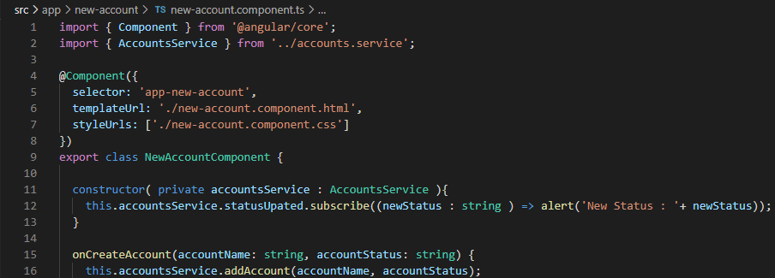

# Assignment: Services and dependency injection

The following are the key features that are to be implemented as part of the exercise.

App Overview: the application has list’s a group of users classified as active and inactive. There does exist a feature to move the user across the groups.

Change 1: Introduce services to reduce data propagation between parent and child component.

Change 2: To create new counter that prints the number of times a user is moved between wither of these groups.

The following snippet provides a glimpse on the present application setup.

Project Structure:

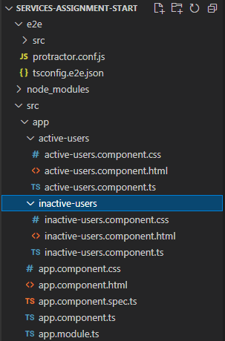

File: app.module.ts

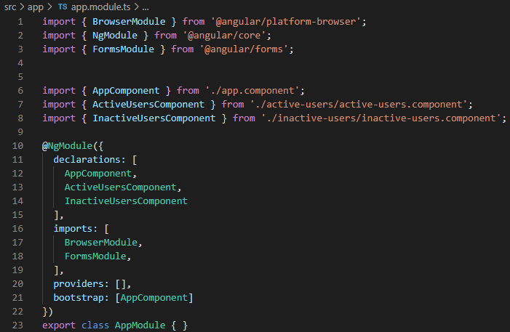

File: app.component.html

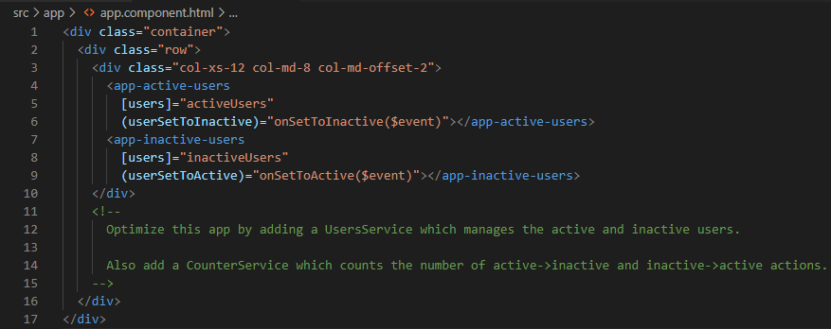

File: app.component.ts

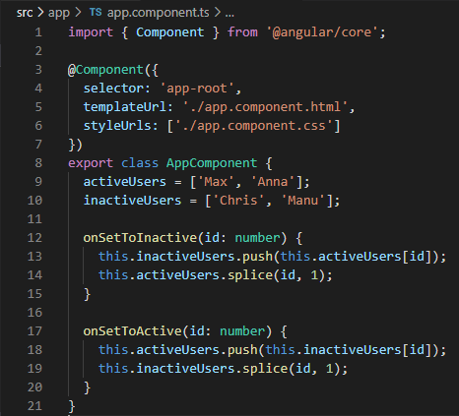

File: active-users.component.html

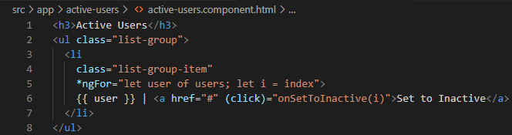

File: active-users.component.ts

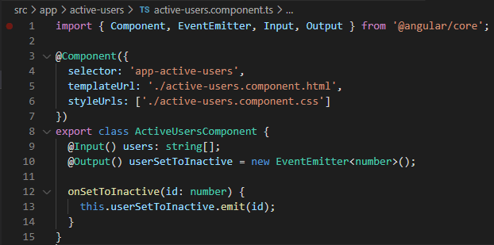

File: inactive-users.component.html

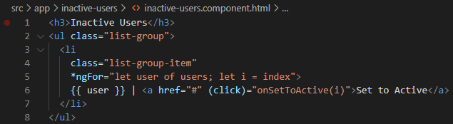

File: inactive-user.component.html

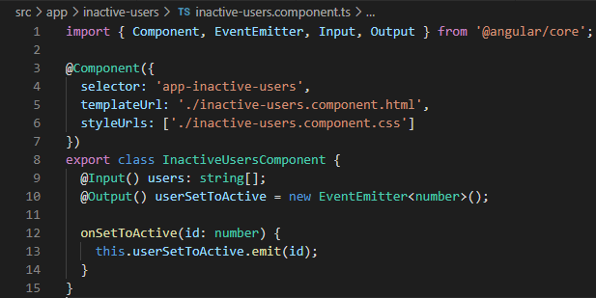

With the above setup, the first step would be to introduce a new service through which the transition of user from active to inactive and the other way around is achieved.

File: users.service.ts

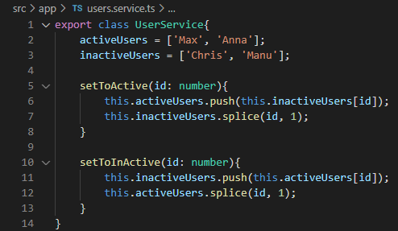

Now that the service is created, the next step would be to identify the hierarchical level for providing the service, in the project structure it can be observed that both active and inactive user’s components are in the same level. Hence providing the service in both components would create two distinct instances of the active and inactive users array.

That being said we will provide the user service in the application component, there by the service will be accessible throughout the project.

Furthermore, on the second part of the assignment we will be creating a counter service to track movement of user from active to inactive group and vice versa.

File: app.module.ts

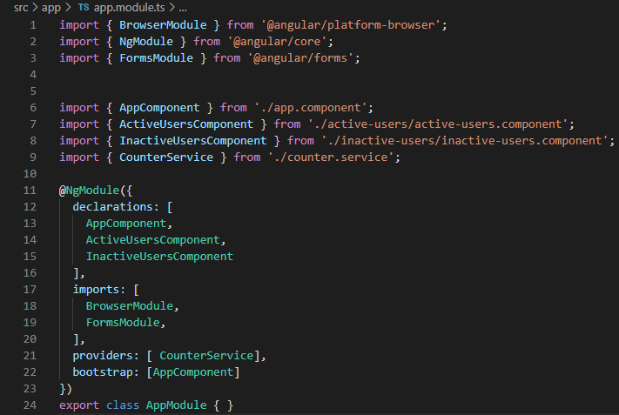

File: app.component.ts

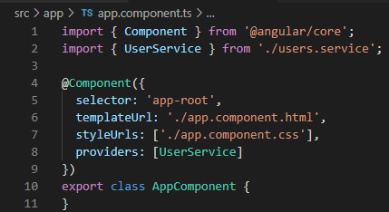

File: app.component.html

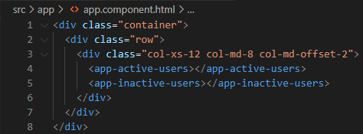

File: counter.service.ts

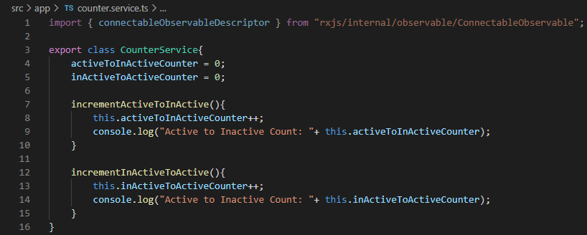

File: active-users.component.html

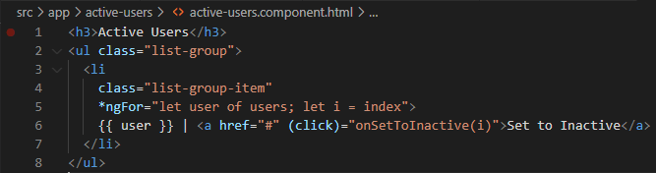

File: active-users.component.ts

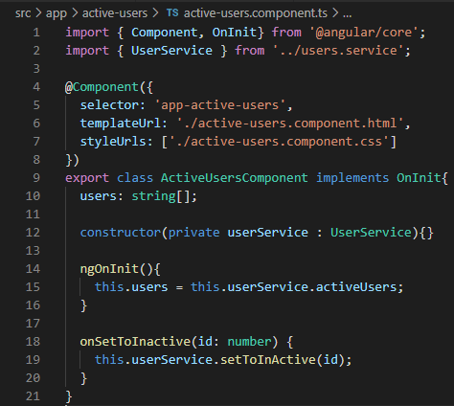

File: inactive-users.compoenent.html

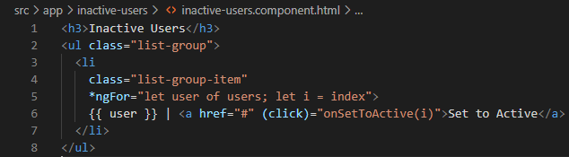

File: inactive-users.component.ts

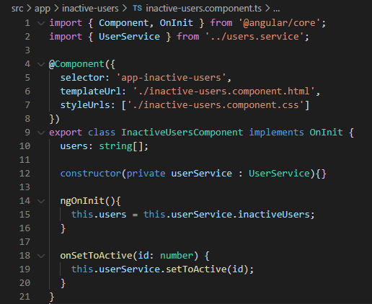

# Enhancing Recipe – Shopping application with services

As part of the upgrade we will introduce 2 new services to the application where in the first one to manage the shopping list and second service to handle recipe list. The following snap shot illustrates the high-level view of the application.

Note: The recipe service will in turn have access to the shopping services.

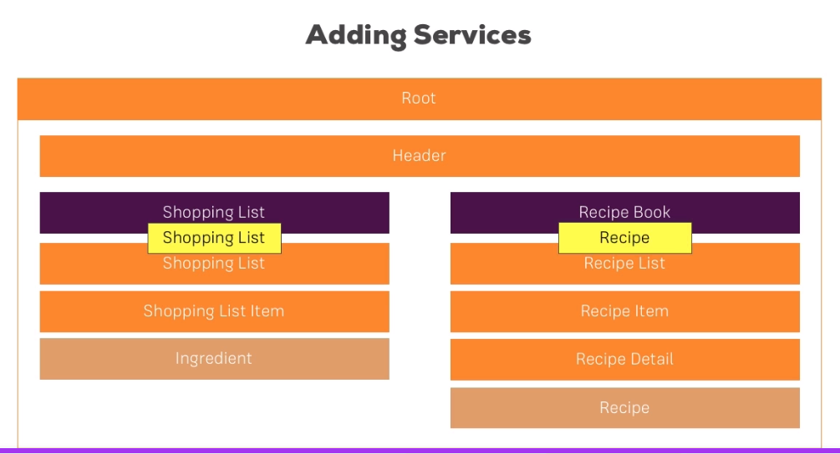

As a first step, we will introduce a new service to manage recipe array list and the same will be declared in the recipe.component.ts by doing so the service will be accessible by both recipe list and recipe detail sub components.

It can be observed that he getter for the service is used in conjunction with the slice method, which returns a copy of the array during each invocation.

File: recipe.service.ts

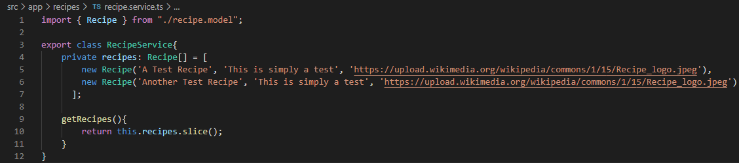

File: recipe-list.component.ts

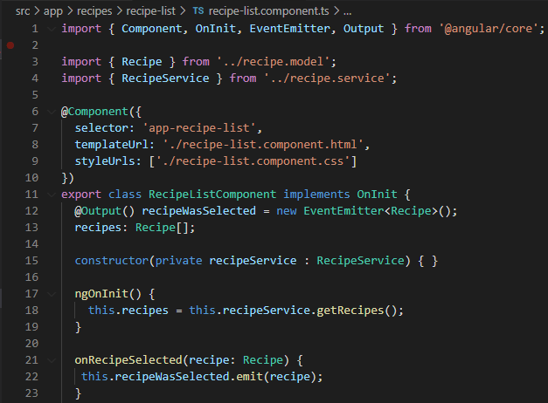

**The following section intended to provide a glimpse on the present application setup.**

File: recipe.component.html

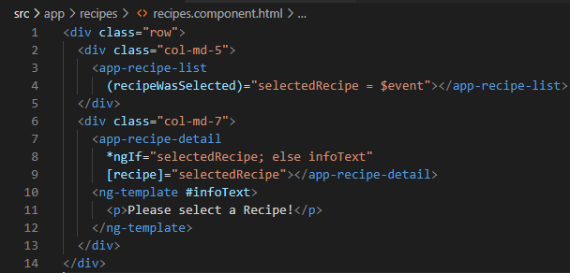

File: recipe.component.ts

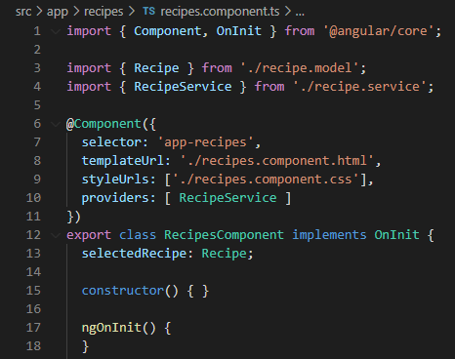

File: recipe-list.component.html

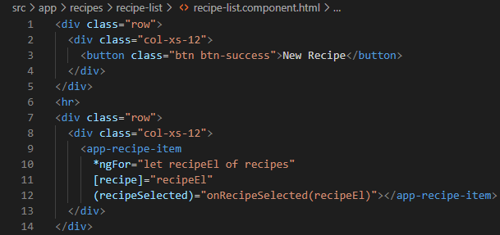

File: recipe-list.component.ts

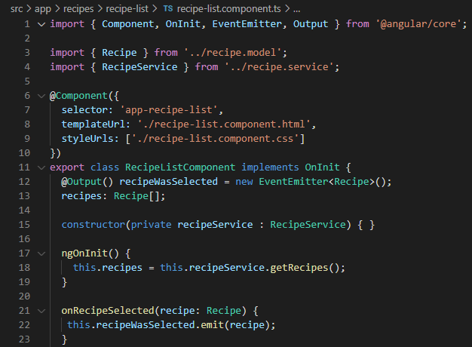

File: recipe-item.component.html

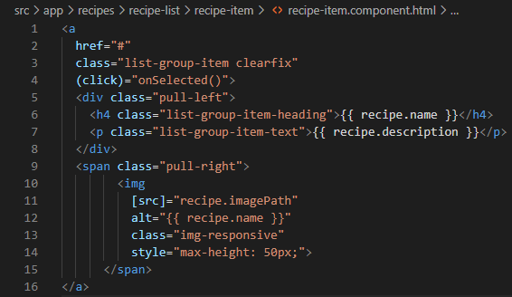

File: recipe-item.component.ts

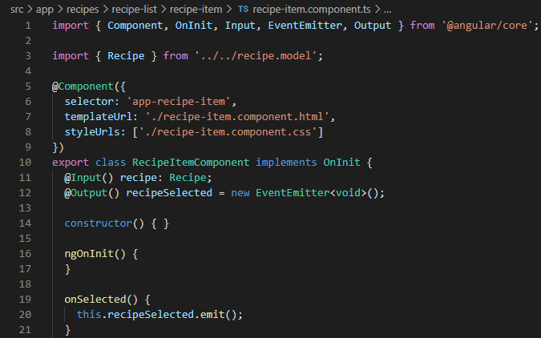

File: recipe-detail.component.html

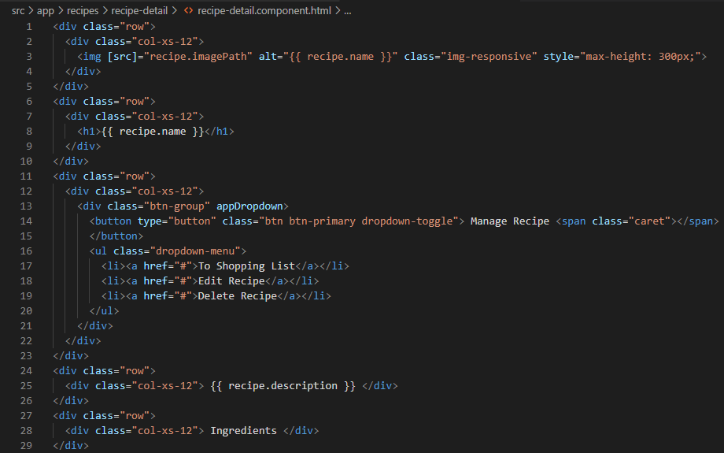

File: recipe-detail.component.ts

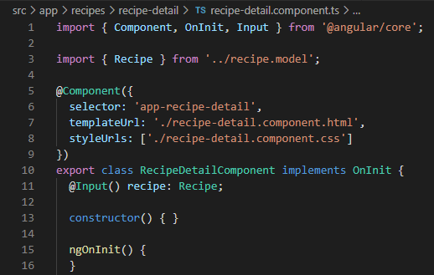

# Cross Component Communication through Services

In the present implementation through, the recipe data propagation is as described below.

Recipe-Item -> Recipe-List -> Recipe Component -> Recipe Detail

By using Service for cross component communication, we will redefine the flow as follows.

Recipe-Item -> Recipe Component -> Recipe Detail

File: Recipe-item.compoenent.ts

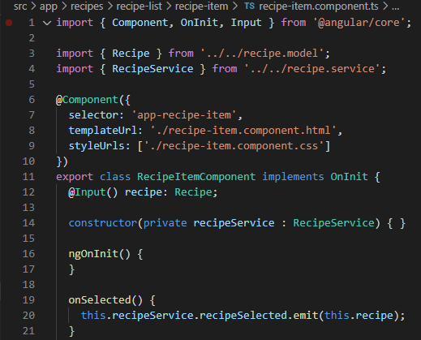

File: Recipe-list.component.html

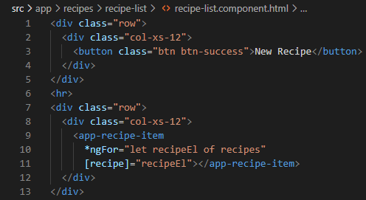

File: recipe-list.component.ts

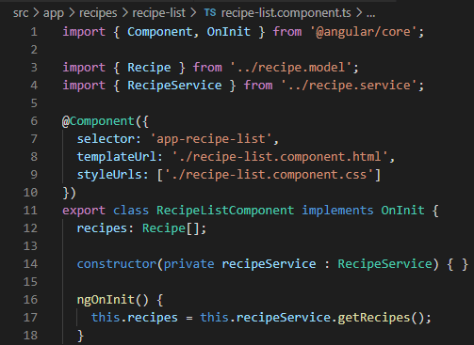

File: recipe.component.html

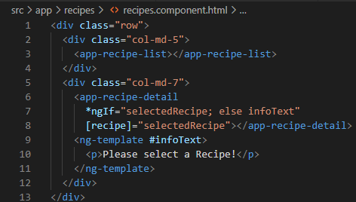

File: recipe.component.ts

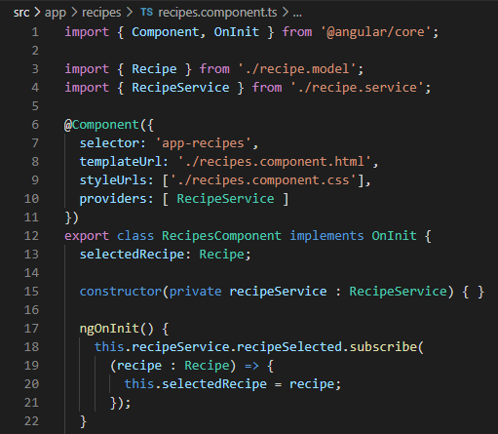

File: recipe.service.ts

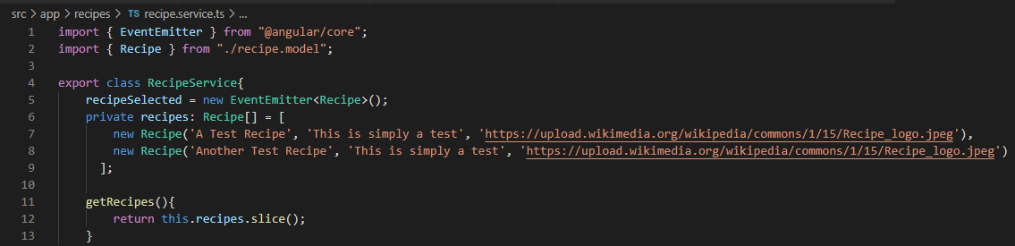

Similar to the above-mentioned example, the cross-component communication through services will be implemented to the shopping list component as well.

To start off let’s have the following section to provide a glimpse on the present code base for comparison purpose.

Project Directory Structure:

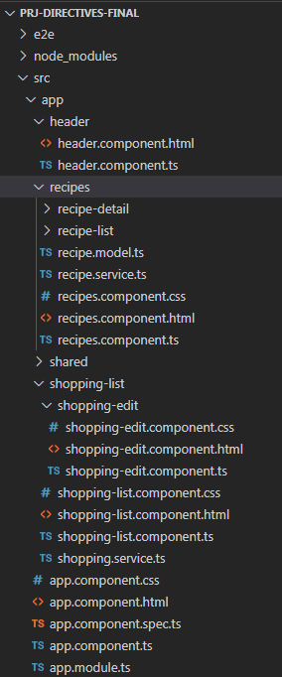

File: app.component.html

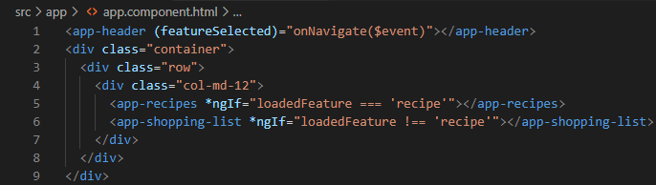

File: app.component.ts

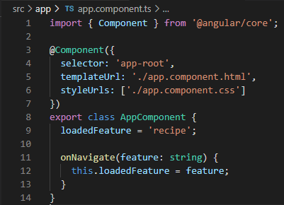

File: header.component.html

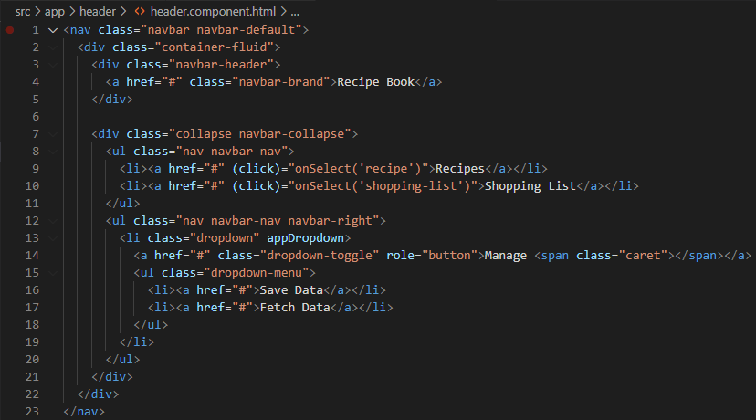

File: header.component.ts

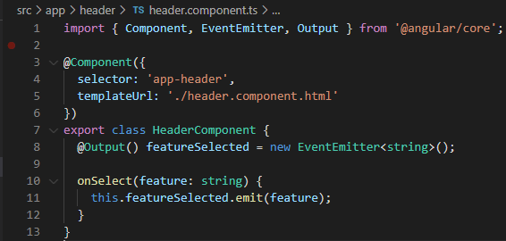

File: shopping-list.component.html

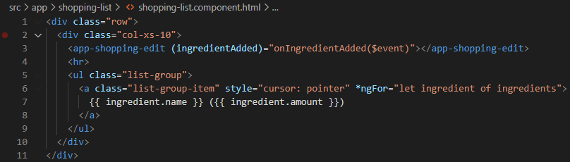

File: shopping-list.component.ts

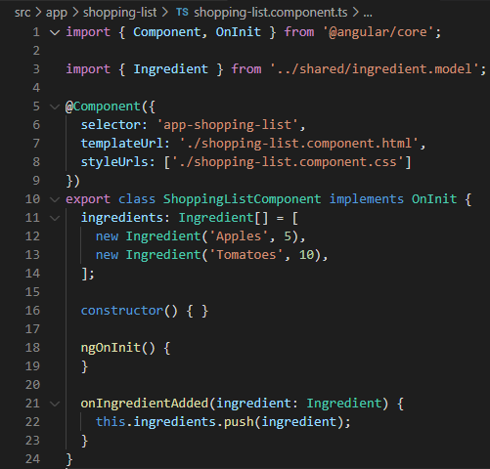

File: shopping-edit.component.html

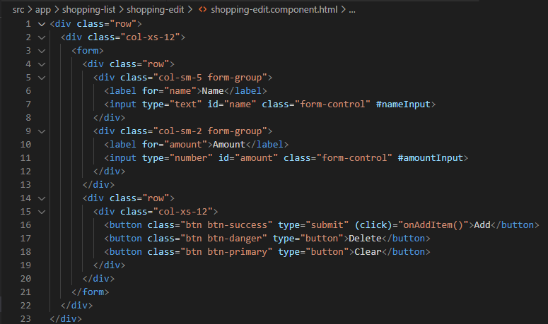

File: shopping-edit.component.ts

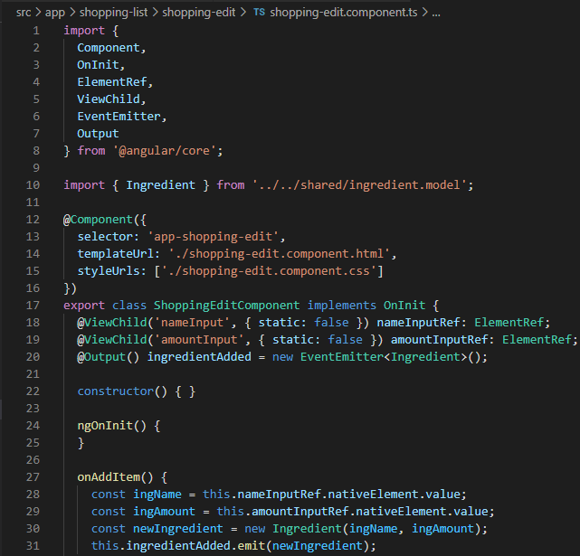

Furthermore, in the present implementation the addition of a new ingredient to the shopping list happens through a series of events emitted from shopping edit to the shopping list component. Which will be refactored to use services.

In the following example it can be observed that whenever the ingredients array is changed, we do emit a corresponding event to ensure that all the reference across other components can be updated.

In our case a copy of the ingredients array is created in shopping list component and an update is initiated in shopping edit component, that in turn triggers an “Ingredients changed” event which will be captured and acted upon in shopping list component.

File: shopping.service.ts

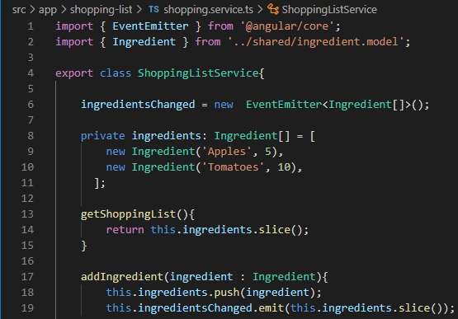

File: app.module.ts

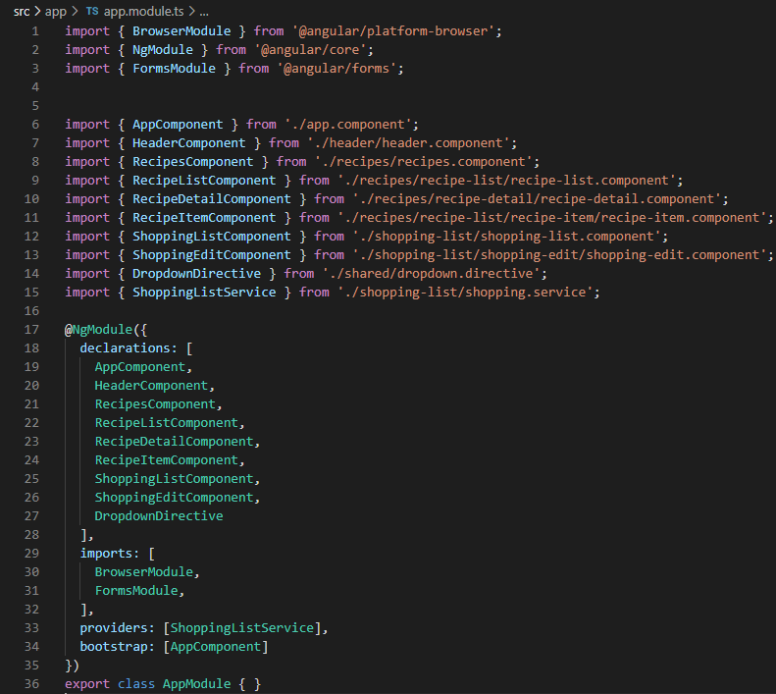

File: shopping-list.component.html

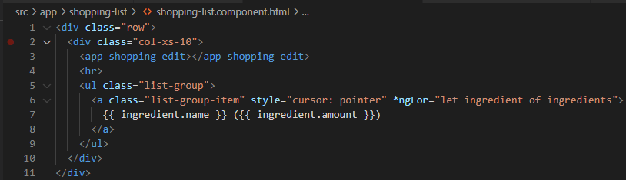

File: shopping-list.component.ts

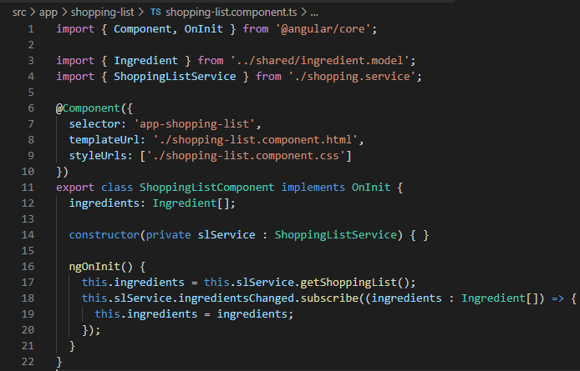

File: shopping-edit.component.html

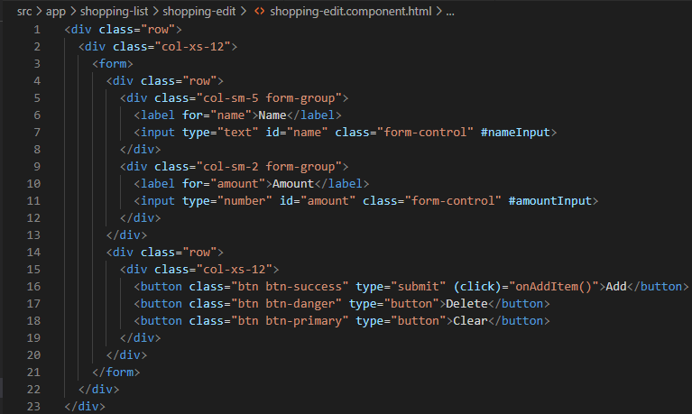

File: shopping-edit.component.ts

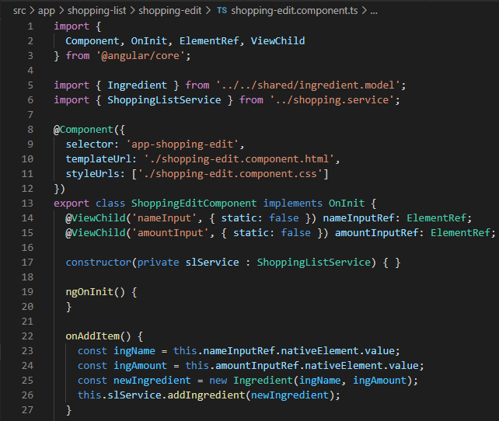

As a conclusion to the enhancements, we will introduce functionality to add the ingredients to shopping list through service.

*Recipe detail (on Add to Shopping list click event) -> Recipe Service -> Shopping list service*

In the following example it can be observed that pushing an object of type array is achieved by the spread operator which internally iterates through all the elements on an array and makes the element available for the push function.

File: Recipe.model.ts

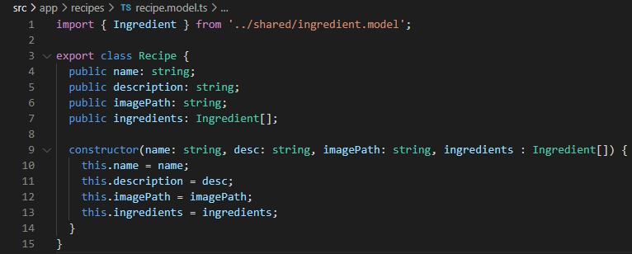

File: recipe.service.ts

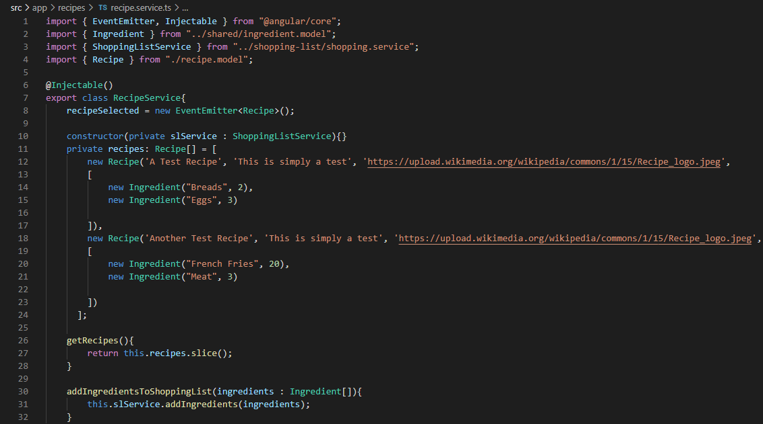

File: Recipe-detail.component.html

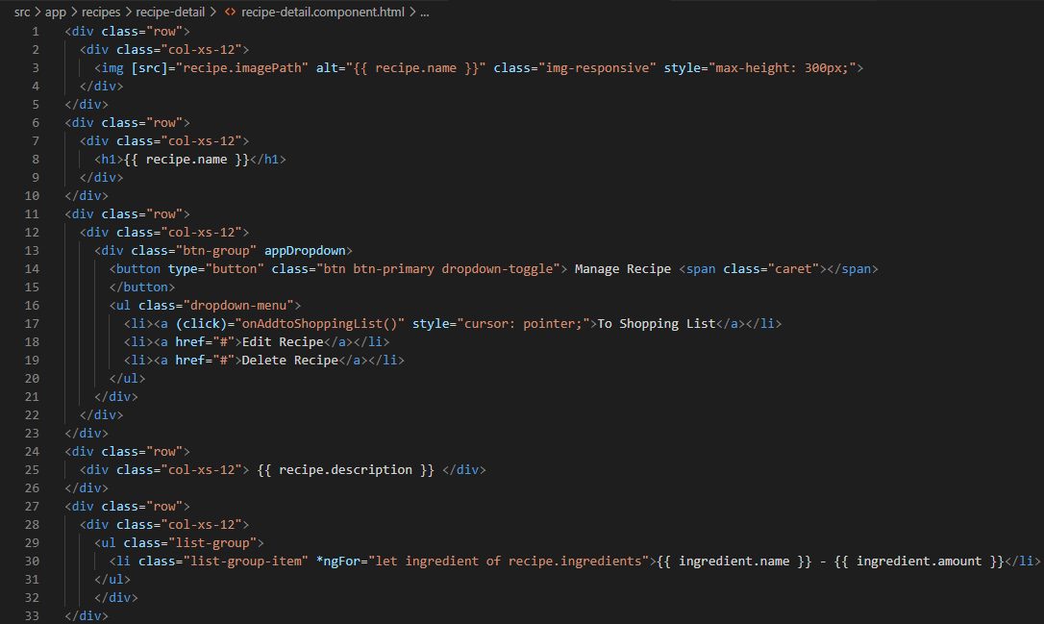

File: recipe-setail.component.html

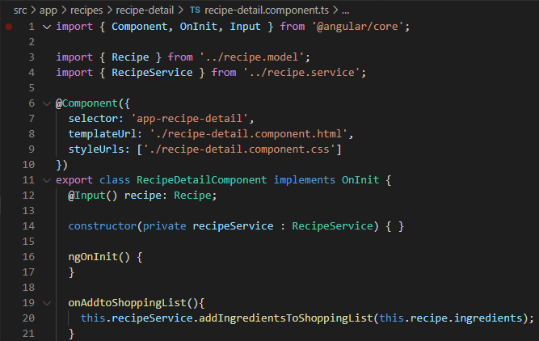

File: shopping.service.ts

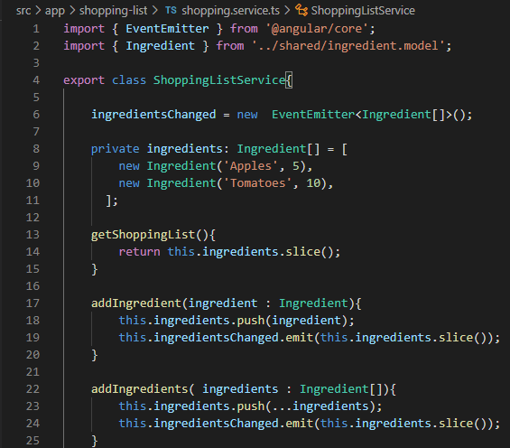

Output: Recipe Tab

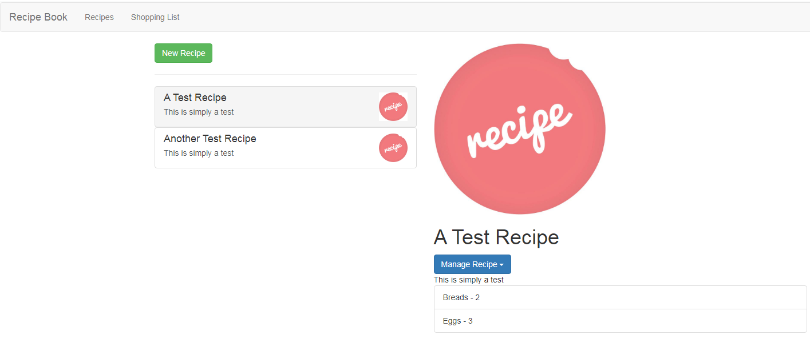

Output: Shopping List Tab

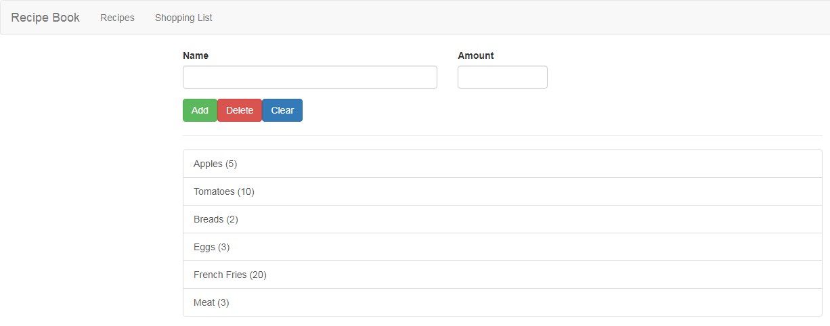

# Routing

The following section details built in functions that allows traversal to all the pages of an application with reloading itself.

Application setup:

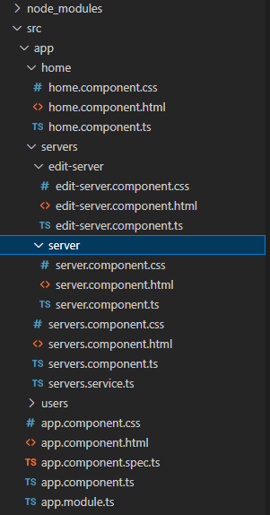

File: app.module.ts

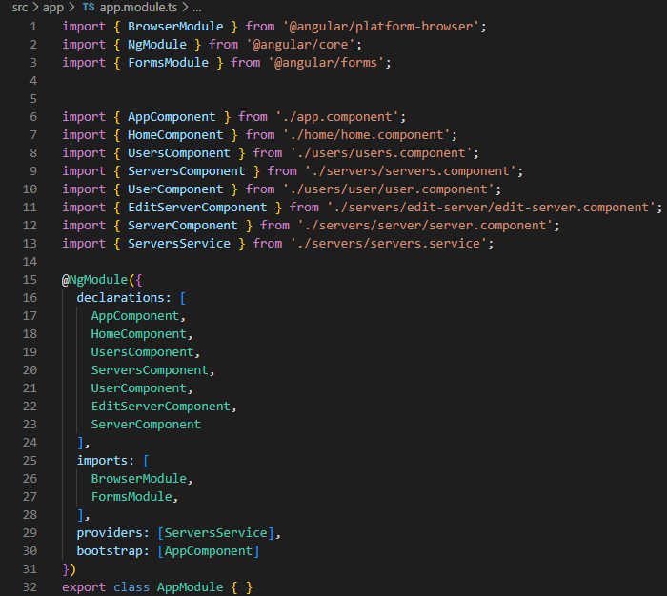

File: app.component.html

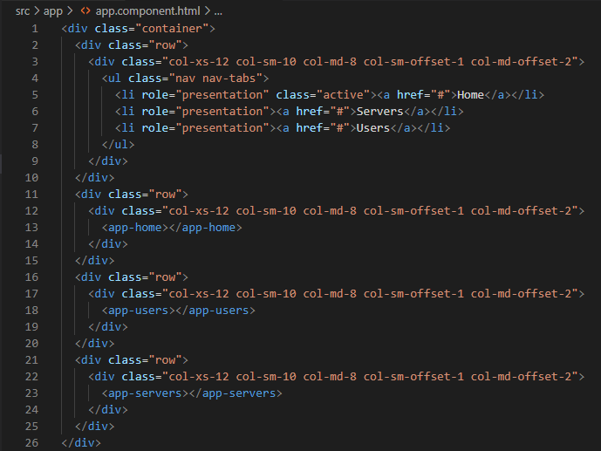

File: app.component.ts

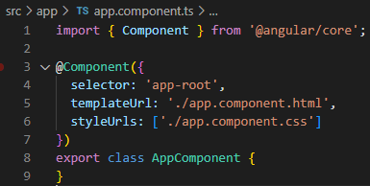

File: [home.component.html](http://home.component.html)

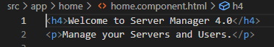

File: [home.component.ts](http://home.component.ts)

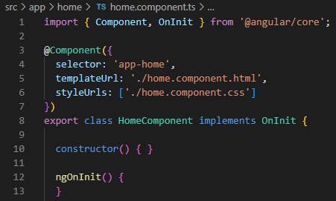

File: servers.component.html

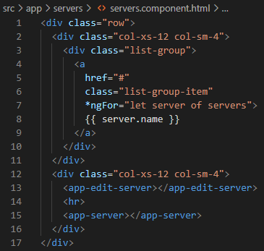

File: server.component.ts

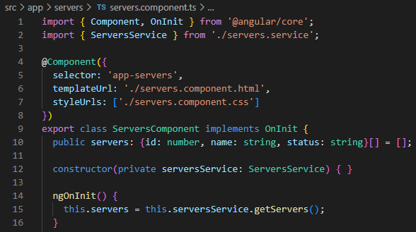

File: edit-server.component.html

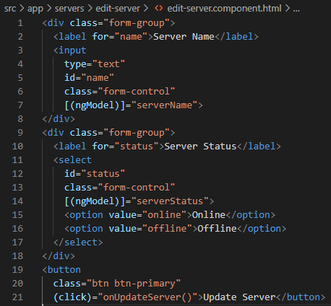

File: edit-server.component.ts

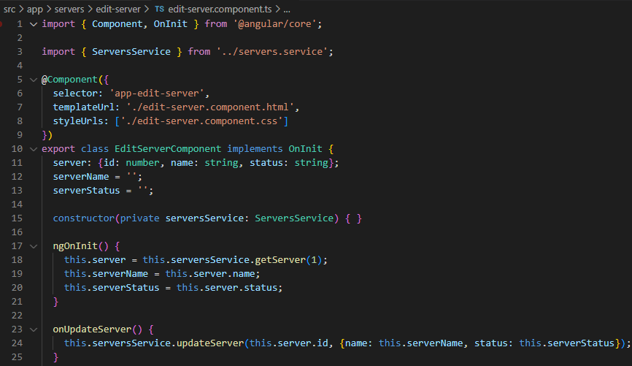

File: server.component.html

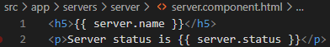

File: server.component.ts

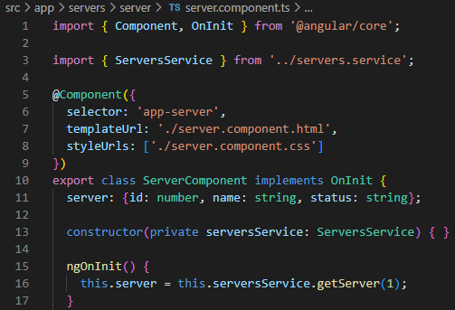

File: users.component.html

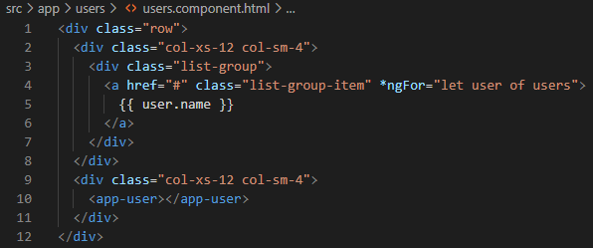

File: users.component.ts

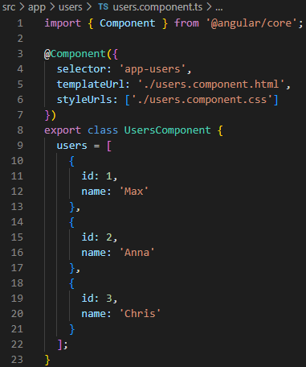

File: user.component.html

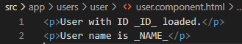

File: user.component.ts

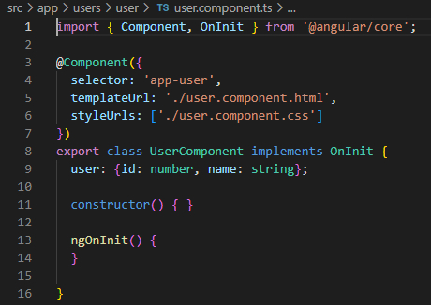

## Creating a router

The first step is to create a constant that has all the route to component association as an array.

Followed by importing the router module with the invocation of forRoot method which takes the router array as an argument.

The forRoot method creates and configures a module with route provider and directives.Optionally it also creates an application listener to perform initial navigation.

File: app.module.ts

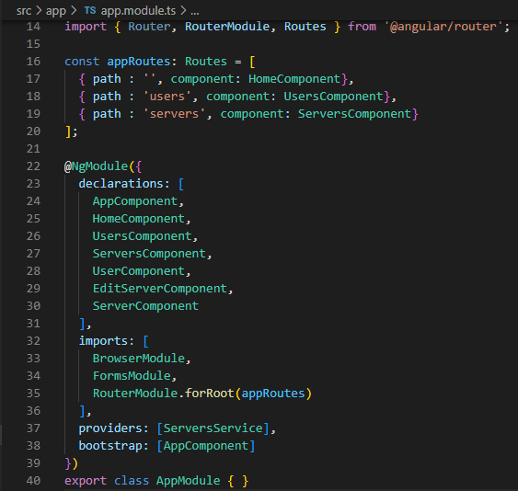

## Defining a place holder for rendering the component of router

The placeholder is defined with the help of router-outlet tag that angular dynamically fills based on the current router state.

File: app.component.html

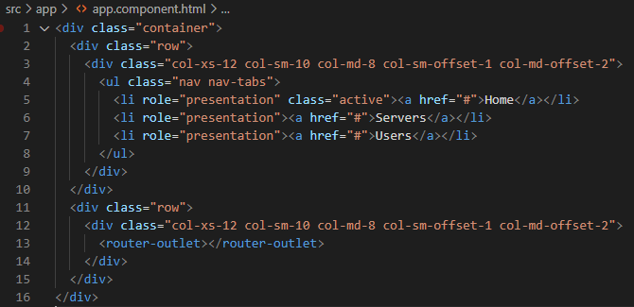

Output: /users

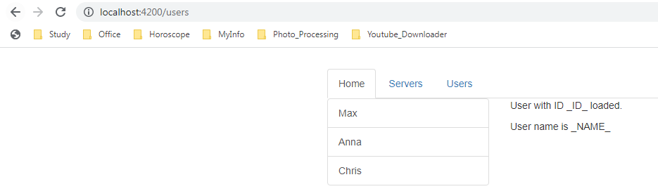

Output: /servers

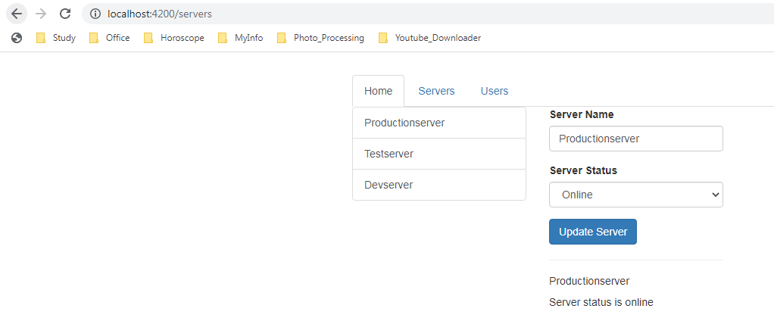

# CSS

## Tag: div

The <div> tag defines a division or a section in an HTML document. The element is often used as a container for other HTML elements to style them with CSS or to perform certain with JavaScript.

## HTML Classes

The HTML class attribute is used to define a uniform style characteristic across multiple elements.

# Reference